V. Workman – “It’s Alive”
Context and Reasons for the Technology-Enabled Tool:
I chose Google Sheets as a tool for students in my Intro to Project Management class. This tool will be used as part of the group project, where students learn and apply PM techniques, including the development of a simple work breakdown structure (WBS). Using Google Sheets is an add-on to Excel, which all students learn as a fundamental business software. Taking their existing knowledge and applying it to the Sheets format will give students a chance to build further fluency and confidence. Practice, practice!

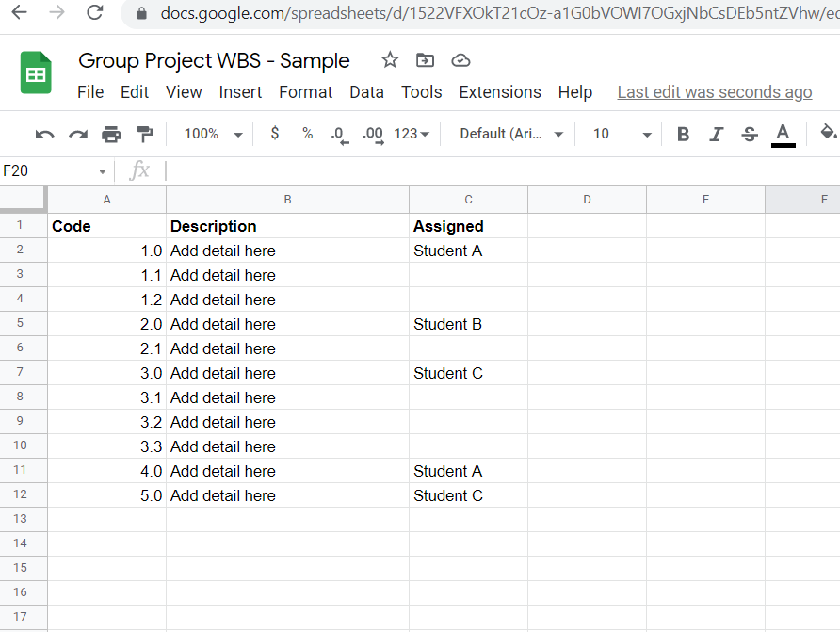

Empathy for Students and Learner Challenge:
Students have been in an “alternate delivery” model for 2 years. The Business Program is full of group project work. These assignments have proved to be very challenging for students on many fronts. Students don’t know each other as well, feel isolated in their homes, have family and work responsibilities which do not allow them common opportunities for collaboration. The challenge of students not being physically together to collaborate and discuss ideas in real-time is one that the tool could assist with. Real-time discussion forms team bonds, which are essential to build trust and open communication, and a more successful project outcome!
Using a collaborative tool like Sheets provides the “real-time” element to this activity within the group project. Students can make use of MS Teams as well and use web cam/mic so they can discuss the activity as it evolves.

Steps in Prototyping and Planned Implementation:
I used the planning template provided to work through each step of prototyping. I began with research on the tool itself and spent time playing around with its features, making edits and comments. I reviewed the available tutorials and LinkedIn Learning support so I could add those as links for students who wish to learn more. Through this process, I sketched out the basics of an instructional video, using point form. I created a basic script that will be used a basis for creating the video, along with a live feed of me setting up a new Sheet.
The video will be posted on our LMS, using Panopto, and will walk through how to approach this activity using Sheets. The video is meant as a teaser, and not to provide all the answers. Allowing students class time for experimentation and trail and error is something I will build into the course.
I have learned over time to build in synchronous group project time into my online classes. Students have provided feedback that they find this very helpful and have scheduled those opportunities with their teams.
As implementation, I will model the use of Google Sheets in other parts of the course. I will build learning and experimentation time into the weekly timetable, using break-out groups in MS Teams. I will ask for comments/questions along the way. Students complete a project reflection at the end and I will include a section on tools to gain feedback on their experience.

