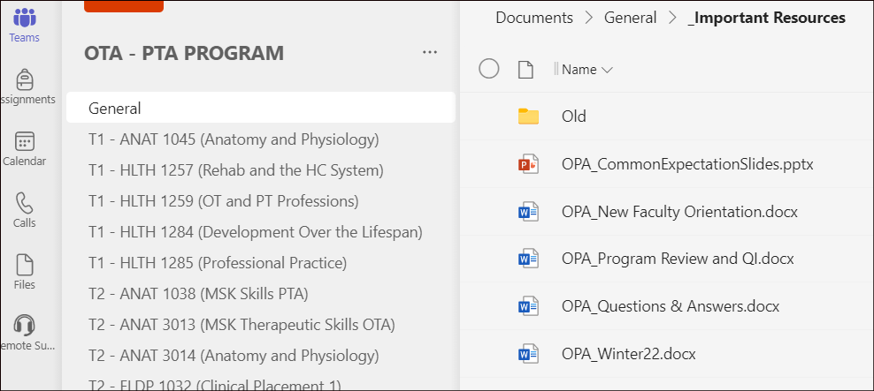

Problem: student frustration with different expectations from each professor for foundational skills/knowledge. For example, different expectations for medical charting, different expectations for Patient Introductions/Identification, etc.
Empathy: frustration, overwhelmed, anxiety, lack of coordination, poor outcomes
Ideating/Prototyping:
- all first year faculty need to identify the foundational items that could be standardized in first year (ie charting, consent, introductions, etc).
- each knowledge/skill item needs to be created/standardized with feedback from faculty
- technology to leverage: MS Teams
  - creation of faculty MS Teams site which offers:
    - security
    - real time editing of documents
    - resource library
    - communication function
Planned Implementation:
- the MS Team has been created, all faculty have been assigned to a Team
- Next steps:
  - Next Faculty meeting: provide prof dev for MS Teams
  - Connect with Faculty to identify ‘foundational’ items to standardize (survey)
  - Create templates based on the items identified including content to generate feedback/discussion
  - Seek feedback/discussion via MS Teams (real time, asynchronous)
  - Finalize expectations and create faculty resources (ie PPT)
  - Faculty: leverage these items within first year classes (common expectations across classes/faculty)

