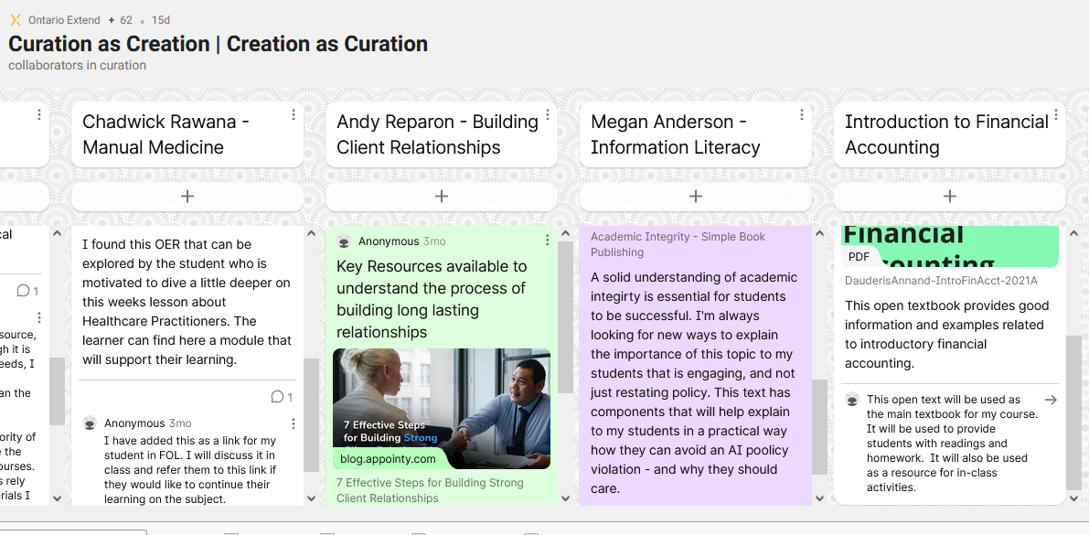

Documentation tool

CRAAP Test
Resource Title:
Introduction to Financial Accounting
Resource URL:
https://lifa1.lyryx.com/textbooks/ANNAND_1/marketingDauderisAnnand-IntroFinAcct-2021A.pdf
Currency: The timeliness of the information: When was the resource published or posted? Has the resource been revised or updated? Does your topic require current information? Are the links functional?
This open text was posted in 2017 and was last updated in 2021. Since this is a resource for introductory accounting it does not need require a lot of updating. Most current information in accounting is more relevant for intermediate and advanced level courses. The links in the text are functional, and the link to the text is functional.
Relevance:&nbsp;The importance of the information for your needs Does the resource relate to your needs? Who is the intended audience? Is the information in the resource at an appropriate level for your learners?
This text meets the needs of the instructors and students for an introductory accounting course. It has many examples. There are some areas where I will add supplementary resources, but it contains most of what I need. It is well-suited to first year business students.
Authority: The source of the information Who is the creator?&nbsp; What are their credentials or organizational affiliations? Are they qualified to write on this topic?
The text is by Henry Dauderis & David Annand, Adapted by T. Jensen. I am not familiar with the original authors, but the open text was adapted by Athabasca University which is a credible source. I have also reviewed the information in the text andam satisfied that the information is appropriate.
Accuracy:&nbsp;The reliability and truthfulness of the information Is the information supported by evidence? Has the resource been reviewed or refereed? Are there spelling, grammar, or typographical errors?
The information in the book agrees with my knowledge as a CPA. The book was adapted from its original form by Athabasca University. I have not noticed any significant spelling, grammar, etc. type of errors.
Purpose:&nbsp;The reason the information exists Why does this resource exist? (to inform, teach, sell, entertain, or persuade?) Is the information fact, opinion, or propaganda? Are there political, ideological, cultural, religious, institutional, or personal biases?
This is an open source textbook which was put together for the purpose of teaching entry-level college and university accounting courses. The majority of the information is fact or interpretations of accounting guidelines and regulations.
Notes:&nbsp;Are there additional questions or observations you have about this material that affect your decision to use it? (i.e. this is an opinion piece that I will use to demonstrate one side of an argument).

Final Recommendation:&nbsp;Will you use this resource? Why or why not?
Yes I will use this resource as it sufficiently covers the topics and meets the needs of the course, and it will save students a significant amount of money

