Mind Map
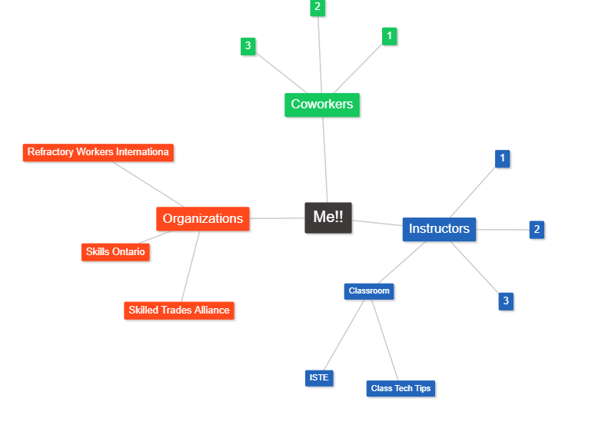
My go-to Instructors are an incredible resource. I kept other co-workers separate, because I go to them with different questions or scenarios. The Organizations node includes some new groups. I put new classroom branches out, since I will be leveraging those organizations for classroom specific information. What I wasn’t able to draw was that some of these should have lines together, since people are connected to some of the organizations! Although I choose to keep names out, the Instructors/Coworkers are fantastic and there is great 2-way communication with those. My classroom node will be one way, where I just read and follow. There will be some interaction with the Organizations, but mostly again I will be following.

