Misunderstood – Unauthorized Collaboration

I am in my first semester/year of teaching and my classes are heavily international students. I am finding that students are having a hard time understanding the term “unauthorized collaboration” and it being a form of cheating. At the beginning of the semester, I verbally go over academic integrity to the students, the importance of it and the consequences of not abiding by the academic integrity for Conestoga College. In my course shell, the academic integrity website for the college is provided to the students. The students are to go to the website, read it, and complete a quiz stating they understand and will abide by the academic integrity for the college.
Being an individual who was born and raised in Canada and therefore I was a domestic student. Having a professor explain academic integrity to me and giving me the resources where I can find the academic integrity for the institution I am attending; would have been something I would have taken seriously. Furthermore, if there was something I did not understand I would ask questions. What I have found with my international students is that most of the time they will not directly ask the professor questions, but would rather go to their peers who grasp the concept. I would later learn that this is the culture for many international students depending on the country they come from. I have also found that many of my international students would rather see visuals of what I am trying to convey to them in order for them to fully understand.
Being a small business owner who creates digital prints (Ayaan’s Crafty Creation), I decided to create comic strips using my paid Canva account; in which I have the appropriate licences to use the graphics provided by Canva. Since I noticed my students wanting a visual which gives them examples; I thought I would make if fun with comic strips, but at the same time getting my message across to the students. Below is an example of a comic I used for one of my classes explaining the importance of doing their own work:
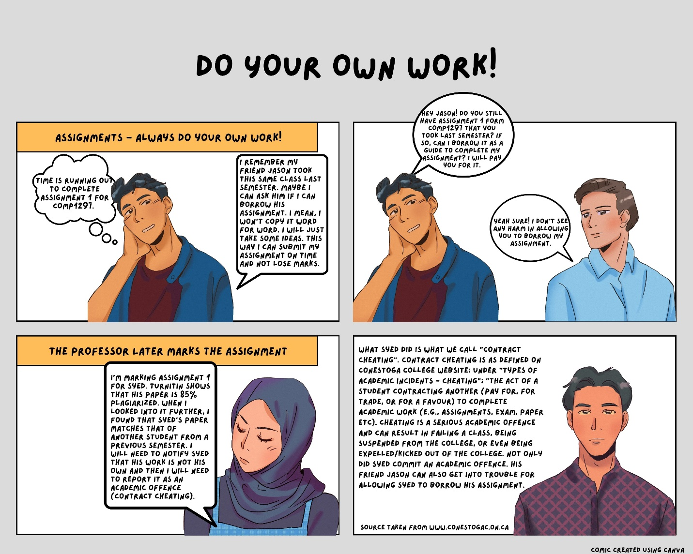
Comic created using Canva (Ayaan’s Crafty Creation paid account)
A comic strip like this would generally be posted the day I release an assignment to the student. Before I share the assignment details with the students, I would go over this comic strip as a class. So far, this method seems to be working for my current semester of students. As I continue my teaching career; I plan on learning more ways and being more prepared to convey my message to students.

