PLN
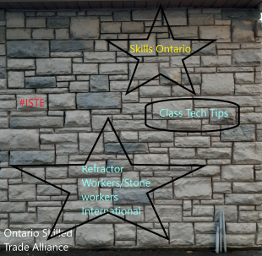
I choose this stone wall in the background to represent that different connections have different values. Some are larger and will be used more often, or might have more interactions. Some are smaller, but help created a varied PLN.

