My initial motivations for taking these modules were to find additional digital tools of value to integrate into my course and find ways to increase engagement and learning. My focus started to change after completing just a few of the units, but still thought it would be helpful to find a patch that would speak to this and give me some answers. However, after scrolling through and reading those I thought were related to my search it was the artwork and title of Bigfoot and Blind Spots – Respecting Students, that caused me to pause. (See attached)
There were several sentences and paragraphs that spoke to me, but one stood out since it was related to one of the earlier topics of prior knowledge, which caused a shift in thinking for me. Fogarasi (2017) said:
“It’s important to respect students’ backgrounds when presenting daunting challenges in a new milieu that can belittle students’ previous experiences. This is true for foreign and marginalized Canadian students. Skills professors with advanced degrees deem as given are cultural constructs many students have never encountered. Academic customs echo their narrow gendered, racial and class-based pedigree. Respect demands the difficult task of introducing academic expectations without devaluing other ways of knowing.”
This paragraph made me realize that I was not spending enough time on integrating what I now see as part of the foundation for creating an open and truly respectful learning environment. I have at times been preoccupied with revising my course shells, the content, assessments, rubrics and learning activities to “help” my learners be successful. I should also put time into incorporating informal discussions, activities, and feedback to find out what they already know, want, and need.
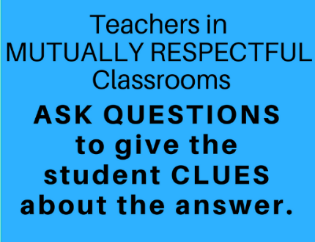
Brown, T. (n.d.) [Respect quote][Picture]. The connection coach.
https://www.pinterest.ca/pin/418905202824183666/

Taking from what George says we need to build bridges across cultures. Therefore, especially for my first semester students, find some time to learn about what their educational experiences are with regards to general classroom behaviour, dynamics between faculty and learner and coexisting and working with classmates. Once I start doing this, I will gain the information I need to know what modifications should be done for how course content is delivered, accessed and assessed that promotes the most learning and can increase engagement.
Fogarasi, G. (2017, May 12). Patch Seven: Bigfoot and Blind Spots – Respecting Students:
Friends Don’t Grade Friends. The Open Faculty PatchBook: A Community Quilt of
Pedagogy https://openfacultypatchbook.org/classroom-skill/patch-six-bigfoot-and-blind- spots-respecting-students/

