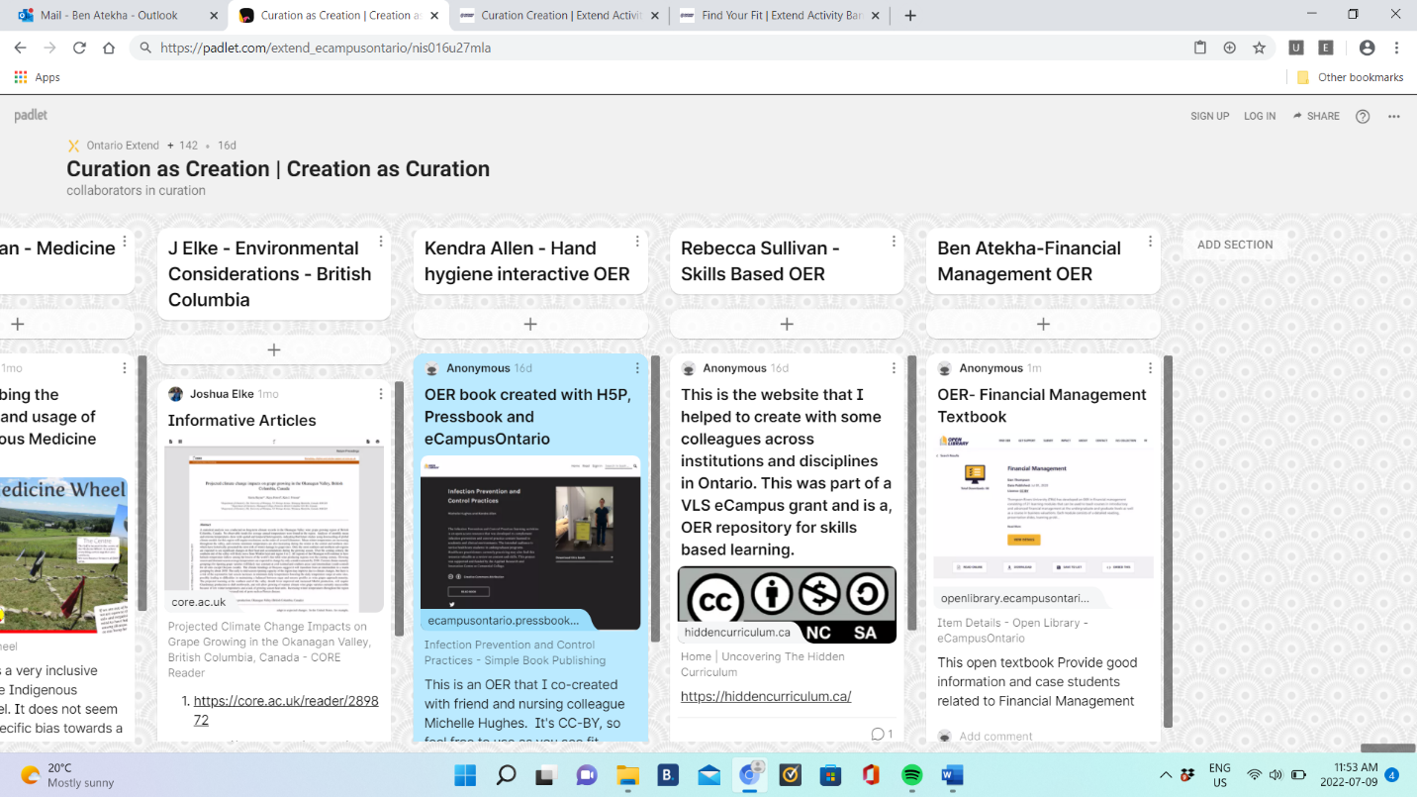

CRAAP Test
Resource Title:
Financial Management
Resource URL:
https://financialmanagement.trubox.ca/
Currency: The timeliness of the information: When was the resource published or posted?
Has the resource been revised or updated? Does your topic require current information?
Are the links functional?
This open text was published on July 01, 2020, and according to author, this textbook is updated annually on June 1. The links for the text is functional.

Relevance: The importance of the information for your needs
Does the resource relate to your needs? Who is the intended audience?Is the information in the resource at an appropriate level for your learners?
I teach finance for healthcare organisation. This open text relates to my need and the needs of my students. I intend to use this text as an additional resource. I particularly love this text because each module consists of an introduction, learning outcomes, along with end-of-reading problems, detailed answer keys, and lecture slides. Case studies and online discussions are also included for use in evaluating students. The 21 modules in this text can be used to teach various introductory and advanced finance management courses at both the undergraduate and graduate levels. I teach graduate level students and this text is appropriate for myself and students.

Authority: The source of the information
Who is the creator?
What are their credentials or organizational affiliations?
Are they qualified to write on this topic?
The Creator is Dan Thompson
The creator Dan Thompson and the book is affiliated to Thompson Rivers University. The Author is currently a teaching professor at Thompson Rivers University and have taught Accounting and Finance for than 10years. At Thompson Rivers University (TRU) modules in this text are used in six courses: FNCE 2120: Financial Management, FNCE 4110: Advanced Financial Management for Accountants, FNCE 4120: Business Valuation and Corporate Restructuring, FNCE 4130: Advanced Financial Management, BUSN 6020: Corporate Finance, BUSN 6210: Advanced Corporate Finance. I believe the author is very qualified to write this textbook.
Accuracy: The reliability and truthfulness of the information
Is the information supported by evidence?
Has the resource been reviewed or refereed?
Are there spelling, grammar, or typographical errors?
The information that I read in this truthful and reliable. This open textbook was reviewed by Professor Kazi Alam. The reviewer wrote that the “text covers all areas and ideas of the subject appropriately and provides an effective index and/or glossary”. The textbook is affiliated to Thompson Rivers University. The section of this textbook that I read did not contain any spelling, grammar, or typographical errors

Purpose: The reason the information exists
Why does this resource exist? (to inform, teach, sell, entertain, or persuade?)
Is the information fact, opinion, or propaganda?
Are there political, ideological, cultural, religious, institutional, or personal biases?
This textbook contains 21 modules that are used to teach a variety of introductory and advanced finance management courses at both the undergraduate and graduate levels either on campus, blended, or online. The information that I read in this textbook are facts and are relevant to financial management.

Notes: Are there additional questions or observations you have about this material that affect your decision to use it? (i.e. this is an opinion piece that I will use to demonstrate one side of an argument).

None

Final Recommendation:
Will you use this resource? Why or why not?
Final Recommendation: Will you use this resource? Why or why not?
Yes, I will use this resource as it sufficiently covers the subject and meets the needs of the course, and it will save students a significant amount of money. Compared to typical finance textbooks, each module in this textbook provides several advantages besides cost. The modules are comprehensive and highly helpful with applications relating to small and large business organizations

