Documentation tool

CRAAP Test
Resource Title:
CRAAP test for Infection Prevention and Control Practices OER
Resource URL:
https://ecampusontario.pressbooks.pub/ipacp/
Currency: The timeliness of the information: When was the resource published or posted? Has the resource been revised or updated? Does your topic require current information? Are the links functional?
2019 - however, not evident from the actual source. It has not been updated recently but information is still current. Not all the links are functional when downloading the OER.
Relevance:&nbsp;The importance of the information for your needs Does the resource relate to your needs? Who is the intended audience? Is the information in the resource at an appropriate level for your learners?
Yes, related to hand hygiene content. The intended is healthcare students in undergraduate programs, however, anybody with basic hand hygiene experience any any college level student could use and understand.
Authority: The source of the information Who is the creator?&nbsp; What are their credentials or organizational affiliations? Are they qualified to write on this topic?
The creators are faculty in community and health studies at Centennial College, a nurse and a nutrition/food service and QA professional. Both are qualified to write on the topic
Accuracy:&nbsp;The reliability and truthfulness of the information Is the information supported by evidence? Has the resource been reviewed or refereed? Are there spelling, grammar, or typographical errors?
Content is supported by Ontario Public Health and Ontario's Provincial Infections Disease Advisory Committee guidelines as well as nursing and food service guidelines. General user would not be able to determine if it was reviewed. No noticeable spelling, grammar errors
Purpose:&nbsp;The reason the information exists Why does this resource exist? (to inform, teach, sell, entertain, or persuade?) Is the information fact, opinion, or propaganda? Are there political, ideological, cultural, religious, institutional, or personal biases?
Content is to inform and teach acceptable hand hygiene techniques Content is fact-based with no noticeable biases.
Notes:&nbsp;Are there additional questions or observations you have about this material that affect your decision to use it? (i.e. this is an opinion piece that I will use to demonstrate one side of an argument).
The OER uses known facts, industry and regulatory bodies supported guidelines.
Final Recommendation:&nbsp;Will you use this resource? Why or why not?
I would use this resource, however, realize it would need to be used directly from pressbooks and it may be necessary to contact the authors for reference requirements.
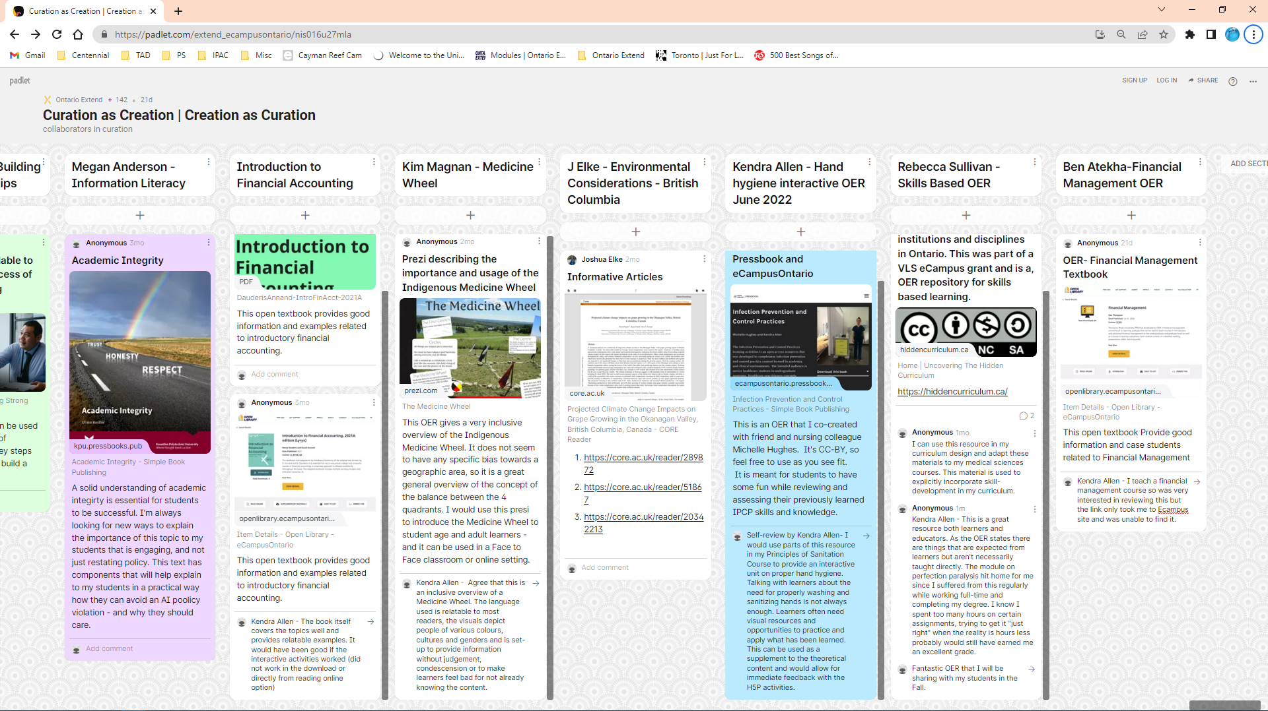
Holy CRAAP Activity Part 2

