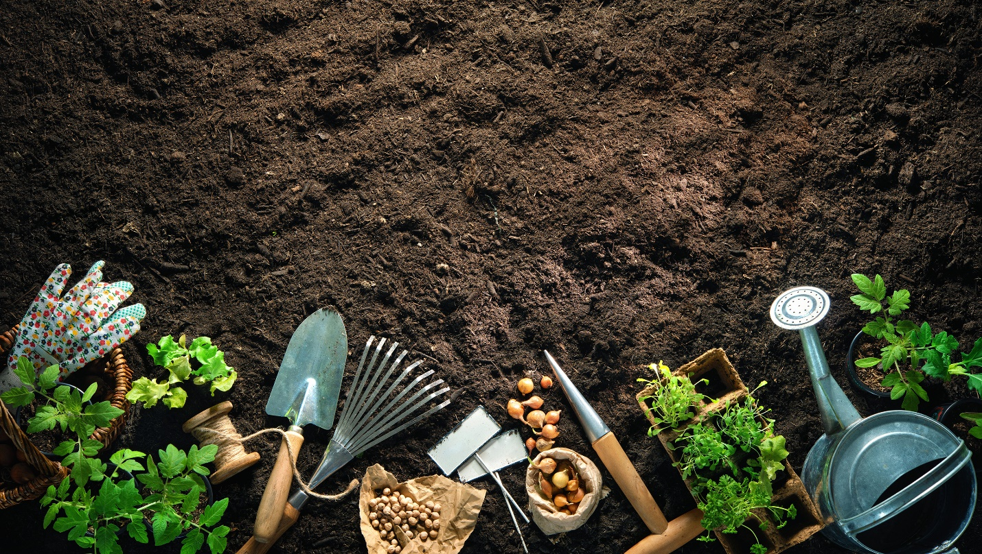

The metaphor that guides my teaching is Teacher as Gardener. However, I think that sometimes as a gardener, I don’t necessarily know what kind of seeds I’m planting. It might be a green bean, which grows and produces results above the soil quickly. Or it may be an oak tree, which can take many years to reach its full maturity. Sometimes as an educator I won’t see the seeds I plant grow to fruition – and that’s okay! I can trust that seeds I plant will make some impact somewhere along the way.