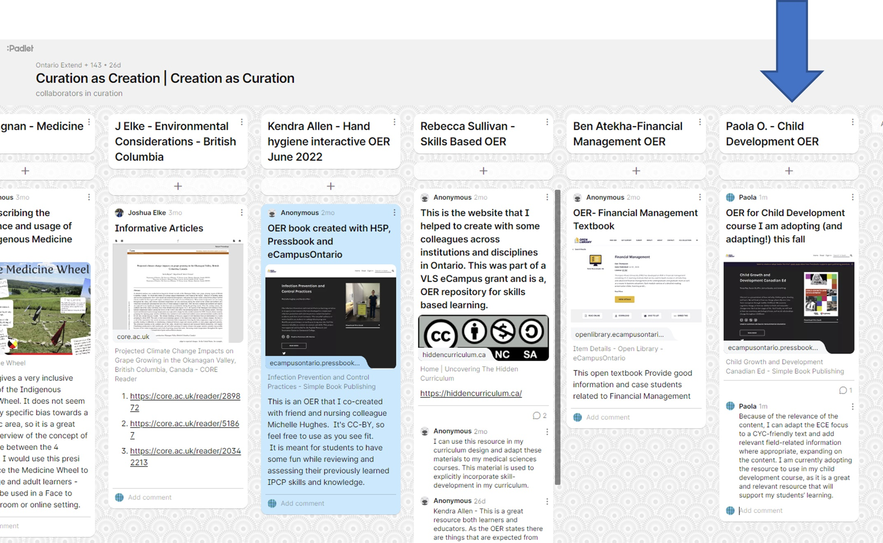
Screenshot of Padlet submission

Documentation tool

CRAAP Test – Paola Ostinelli
(Screenshot of Padlet Submission below)
Resource Title:
Child Growth and Development Canadian Ed
Resource URL:
https://ecampusontario.pressbooks.pub/childgrowthanddevelopment/
Currency: The timeliness of the information:
- When was the resource published or posted?
- Has the resource been revised or updated?
- Does your topic require current information?
- Are the links functional?
The resource was published in February of 2022, adapted by another Open Resource (which was last edited in 2021). References are also relatively up to date, with the most recent reference dating to 2021. The topic of child development has had some updates, but most of the original content is in some cases over 30+ years old. The current Canadian content is helpful, and the links are functional throughout most of the Open Resource.
Relevance: The importance of the information for your needs
- Does the resource relate to your needs?
- Who is the intended audience?
- Is the information in the resource at an appropriate level for your learners?
The resource relates directly to the course I have chosen it for, which is a child development course. The content covers from conception to age 12, which is exactly the ages my course covers. The intended audience are ECEs, however Child and Youth Care has similar information, and in terms of development there is much overlap. For example, the textbook that was used previously, is also used by courses in the ECE program in my department. The information is also appropriate for my learners.
Authority: The source of the information
- Who is the creator?
- What are their credentials or organizational affiliations?
- Are they qualified to write on this topic?
The authors are faculty in the ECE programs at Fleming and Loyalist Colleges, and the authors are Registered Early Childhood Educators in Ontario with relevant field experience, which in my opinion qualifies them to write on this topic.
Accuracy:
- The reliability and truthfulness of the information
- Is the information supported by evidence?
- Has the resource been reviewed or refereed?
- Are there spelling, grammar, or typographical errors?
Content from the OER are from a variety of sources, many peer-reviewed and reputable sources of information in Canada and globally. The resource is published by eCampus Ontario and reviewed/edited by many individuals and professionals. I did not notice any spelling, grammar, or typographical errors.
Purpose: The reason the information exists
- Why does this resource exist? (to inform, teach, sell, entertain, or persuade?)
- Is the information fact, opinion, or propaganda?
- Are there political, ideological, cultural, religious, institutional, or personal biases?
The resource exists to provide Canadian content to ECE students to teach them about child development. The information is referenced from reputable sources, and I did not notice any biases in the authorship other than the content is geared specifically for ECE students.
Notes: Are there additional questions or observations you have about this material that affect your decision to use it? (i.e. this is an opinion piece that I will use to demonstrate one side of an argument).
Observation: Because of the relevance of the content, I can adapt the ECE focus to a CYC friendly text and add relevant field-related information where appropriate, expanding on the content.
Final Recommendation: Will you use this resource? Why or why not?
I am currently adopting the resource to use in my child development course, as it is a great and relevant resource that will support my students’ learning. Yes, I will use this resource!

