Plan for a SoTL Project
by Gitanjali Shanbhag, University of Waterloo
Research Question
What are you curious about?
What would you like to know about strategies that might hinder and/or help students to learn, in your course?
Do you want to know if an activity, assignment, or teaching strategy “works?”
Do you have a question about how to help your students learn a particular skill?
I’m curious about the effectiveness and impact of fully asynchronous online courses on undergraduate students in STEM courses at my university. There is a lot of research that talks about this topic, however, I as an Online Learning Consultant I am interested in assessing the impact on Undergraduate students of my University. I am specifically interested in learning whether the students are able to achieve the course level learning outcomes without in-person classes and face-to-face discussions with instructors or teaching assistants.
Identify challenge/outcome related to learning that is related to your question.
Describe the learning in a way that suggests how you might measure it using either qualitative or quantitative methods.
As an Online Learning Consultant I have access to Student Course Perceptions at the end of each term. Here students talk about their experiences regarding online courses. I could perform quantitative analysis of the data gathered over the course of 2016-2020 and 2020-2022 (the reason I have separated these is to possibly eliminate any trends being seen due to the COVID pandemic). In addition to this, I could conduct surveys and focus groups of students in STEM who have taken 2 or more online courses throughout their undergraduate degree.
Describe the instructional activity, assignment, or teaching strategy that will promote student learning on the outcome you identified.
SoTL projects might investigate the impact of a modification to an existing strategy or assignment. Describe how the new approach differs from the old approach and why this modification might change student learning on this outcome.
I have tried incorporating learning outcomes as part of a final assessment. Students were encouraged to talk about their achievement of each of the course-level learning outcome and describe an example or two to show how they measured their achievement of LO’s. Reading such reflections would be helpful in seeing students perceptions.
Describe the evidence that would persuade an external audience that the new or modified teaching strategy improves student learning on the targeted learning outcome.
Describe the evidence you would need to collect to answer questions about the impact or value of this teaching strategy. How would you convince others that this approach is better than other approaches? What comparisons should you make? Examine students; skill before and after the assignment? Compare students who complete the learning activity to another group of students – what comparisons would be meaningful?
I would need to collect student’s reflections (data that can be de-identified), student’s course perceptions (anonymous data) and any feedback from teaching assistants.
How and where would you publish, present, or disseminate this work?
The first way to disseminate the work would be internally by sharing the results at the Teaching & Learning conference at my institute. An informal way of sharing would be to have a chat with all STEM instructors who teach online courses. This would really help them in redesigning components of their already existing courses. Lastly, I would like to present this at the Digital Pedagogy Conference.
Ethical considerations:
- I had mentioned the use of graded assessments to be able to identify students perceptions on their achievement of learning outcomes in a fully asynchronous online course. In order to get students to opt-in to this SoTL study, we would have to get student’s permissions and if the assessment is graded then due to the power differential (instructor asking student for permission), the students might readily give permission even if they do not want to. To avoid this, permission must be asked after all grades have been submitted and this should be made clear to students.
- Secondly, all reflection assessment data will need to be de-identified before analysis.
- Thirdly, any surveys conducted will need to be evaluated by the ethics office first (in addition to any assessments that are used for the analysis).
Dissemination Plan:
- This study will be done to improve the quality of fully asynchronous online courses at my institution (in STEM) for effective achievement of course-level learning outcomes. The first way to share my results would be a presentation to all STEM instructors who teach such courses. All of the data collected would be from students in their courses and therefore it is important to share the data with them.
- Secondly, I would like to create a report and pass this to the department head for review and to brainstorm ideas with instructors who do not teach online courses. This would also provide current instructors with ideas on redesign. This report should also be disseminated amongst the students who agreed to participate in the study. They should know how their answers and reflections are being used at the Faculty level.
- Lastly, presenting this information at the university teaching and learning conference and the digital pedagogy conference will help other instructors (in non-STEM faculties) learn about our findings and improve/redesign their courses.
My research question: Are students successfully able to achieve (and demonstrate the achievement of) the course-level learning outcomes in fully asynchronous online STEM courses?
Prior research I will undertake: It is known to me that a lot of instructors have done informal surveys in order to improve certain parts of their courses. So it would be helpful to start there, get some of their thoughts and ideas about the study.
Plan of action: Review survey data from student course perceptions survey (between 2016-2020 and 2020-2022), ask instructors to consider adding an assessment to understand student’s perceptions on course-level learning outcomes, conduct student surveys via email and focus groups.
Dissemination strategy: Instructors teaching such courses, students who are participating in the research, department heads and other instructors not teaching online courses, internal conferences.
Direction in which I intend to go with this SoTL project: I need everyone to contribute a piece of information and this picture accurately describes it. TEAMWORK!
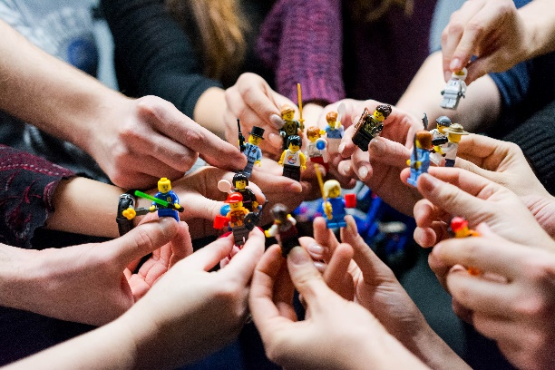
Photo by Vlad Hilitanu on Unsplash

Adapted from: C. J. Stanny, E. M. El-Sheikh, & H-M. Chung (2009) Getting Started with a SoTL Project
Center for University Teaching, Learning, and Assessment http://uwf.edu/cutla/

