Curator Activity #1 – Openly Licensed Image

I decide to search for an image about the “bottom of the pyramid”, which relates to the poor population in an economic system.
My first search was on the Creative Commons Search. I didn’t like most of the pictures, I advanced 5 levels on the “load more results” and it started to show results about the “Fortune Global Forum 2013”.
I selected this image as the one that would be closer to what I would like to show
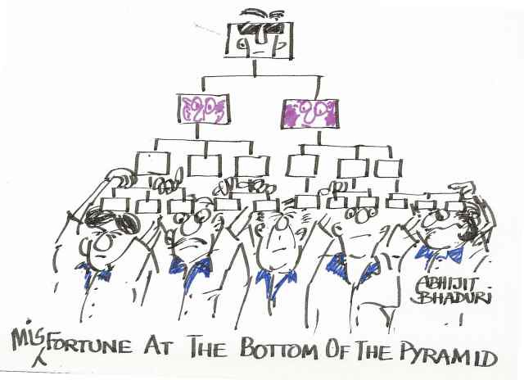

"Fortune at the bottom of the Pyramid" by BhaduriAbhijit is licensed under CC BY-NC-SA 2.0.

Then, I changed my search for “poverty line”. It was the same difficult to find an image, and I selected this one
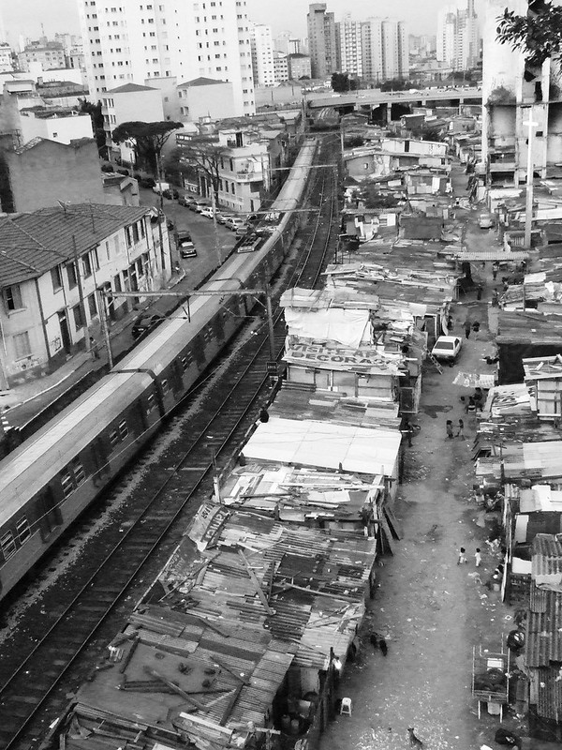

"Favela do Moinho, São Paulo" by Henrique Yasuda is licensed under CC BY-NC-ND 2.0.

Then I repeated the search on Flickr. First for the “Bottom of the pyramid”. Most of the pictures under “all creative commons” were related to the same “Fortune Global Forum 2013” event. Then, I searched for “poverty line” and I didn’t find any image that resonates with he content that I was thinking about.

In conclusion, if I have to choose one of these I would go with the “Favela do Moinho” picture, because it would be the one should the the housing for the bottom of the pyramid people.

