Teaching Metaphor

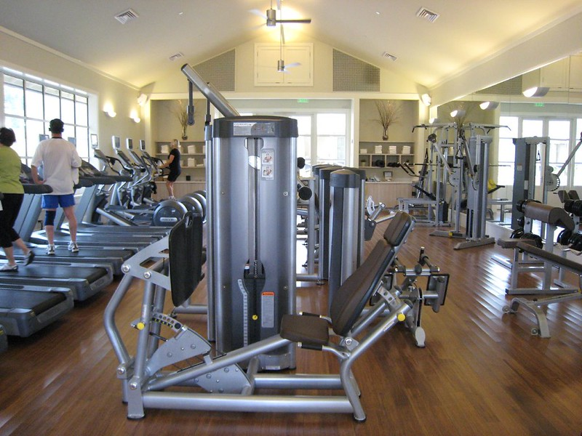
"IMG_2529" by Neeta Lind is licensed under CC BY 2.0.

I selected this image considering the “Muscle Builder” teaching metaphor: “They exercise and strengthen flabby minds so learners can face the heavyweight learning tasks of the future.” Retrieved from the University of Waterloo link provided.
I am a stronger believer that resilience makes the difference when we go to the marketplace, and resilience is built upon exercises. The same can be applied when we are teaching or learning. Our effort will make the difference. I don’t want the students to experience the “No Pain No Gain” saying, but I like t show them that we need to persevere and work hard to achieve good things in our lives.

