Curator – Activity #4 – Holy CRAAP

The First part of the assignment is the screenshot, followed by the complete CRAAP test.

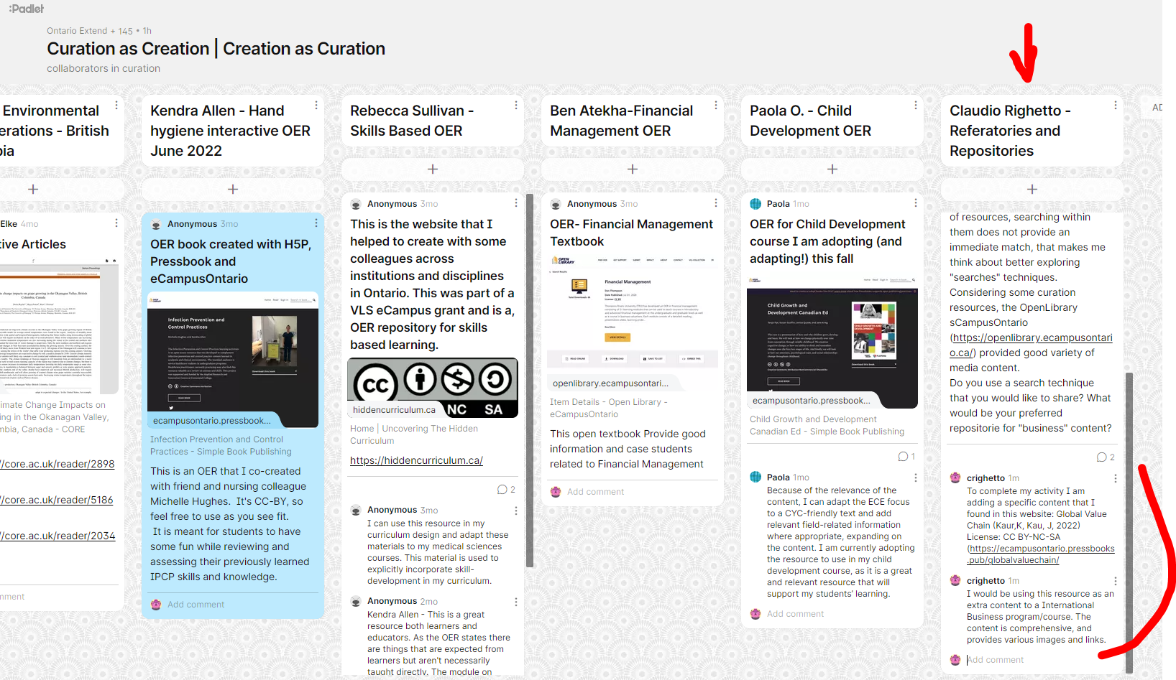

Documentation tool

CRAAP Test
Resource Title:
Global Value Chain
Resource URL:
https://ecampusontario.pressbooks.pub/globalvaluechain/
Currency: The timeliness of the information: When was the resource published or posted? Has the resource been revised or updated? Does your topic require current information? Are the links functional?
Date Published: Jul 07, 2022; recently published, links are functional
Relevance:&nbsp;The importance of the information for your needs Does the resource relate to your needs? Who is the intended audience? Is the information in the resource at an appropriate level for your learners?
The content explore in details the global value chain. Intended to post secondary education (Colleges or Universities)
Authority: The source of the information Who is the creator?&nbsp; What are their credentials or organizational affiliations? Are they qualified to write on this topic?
Dr. Kiranjot Kaur has an MBA and a PhD and she is a doctorate in Business Administration with International Economics and Trade as a major research area. Juliia Kau has as MBA and she is a professor of Global Supply Chain Management, Feasibility of International Trade, and Business Planning for Market Entry
Accuracy:&nbsp;The reliability and truthfulness of the information Is the information supported by evidence? Has the resource been reviewed or refereed? Are there spelling, grammar, or typographical errors?
The books acknowledge different people who collaborate with the authors, it provides a variety of images as well as links to various resources.
Purpose:&nbsp;The reason the information exists Why does this resource exist? (to inform, teach, sell, entertain, or persuade?) Is the information fact, opinion, or propaganda? Are there political, ideological, cultural, religious, institutional, or personal biases?
This resource exists for teaching, and I didn't identify any bias
Notes:&nbsp;Are there additional questions or observations you have about this material that affect your decision to use it? (i.e. this is an opinion piece that I will use to demonstrate one side of an argument).

Final Recommendation:&nbsp;Will you use this resource? Why or why not?
I could use this resource as an extra content, to show students who are willing to learn more about the topic.

