Activity 6: Thought Vectors and Nuggets
When looking at the choices in the Open Faculty Patchbook, I found Patch 31 – ID Soft Skills interesting. Sometimes I wonder that because we live in such a digitally-driven world, do we lose sight of the importance of developing the “soft skills”. These soft skills pertain to faculty and their instructional skills as well as for students and their humanistic skills of interaction and awareness. Sometimes we feel that teaching through the use of technology enhances student learning and student development. Does it? Maybe not always. This brought my thinking back to the sketch provided earlier in this module (see below).
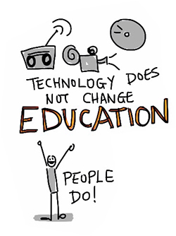education.jpg?_&d2lSessionVal=AMyOb1DgOj1voWeF42hL1oQta&ou=6714

https://coi.athabascau.ca/coi-model/

