Golden Nugget Activity

My golden nugget comes from the article titled “Promoting Disagreement: How to Debate and Not Die”. The following is an excerpt from the beginning of the article which really resonated with me: “However, despite the potential difficulties that come along with disagreement, it is essential in a classroom setting for intellectual engagement and development.”

The reason I chose this idea was because it is highly relevant in the field of medicine which I teach. In my field there is a degree of subjectivity, and not all cases are black and white. There are many times which I have disagreed with colleagues, and learning how to approach these conversations was difficult at first, but I felt that overtime it taught me a great deal in not only my subject matter, but also in how to deal with others when they disagree with me or vice versa. How to defend one’s idea without coming across as rude, or stubborn is a good skill to learn, as these discussions can lead to both sides learning a lot from one another. It also strengthens relationships in the long run, as we become more comfortable disagreeing respectfully, and are not worried about sounding “dumb” or making mistakes. This is particularly important in the classroom, as we all strive to make our environment one that is safe to make mistakes in, and to ask questions. I truly believe that allowing and encouraging respectful disagreement is an important part of a classroom, and any relationship which we wish to be a safe and comforting one. We get to learn more about each other’s perspectives, as we all have had different life experiences which shape our view of the world.

This reminded of a large debate that ensued online, when a picture of a dress was posted and many thought the dress was blue/black, whilst another group thought the dress was white and gold:
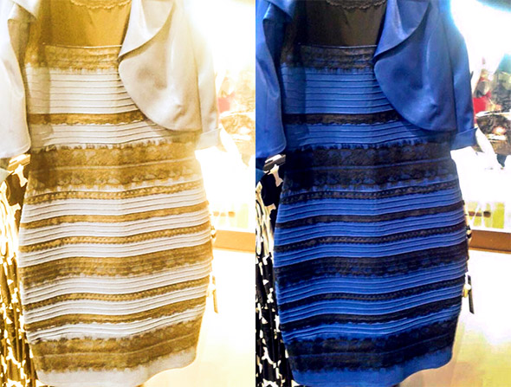

A recent explanation was that “… if you assumed the dress was in a shadow, you were much more likely to see it as white and gold”. This shows how important understanding context and perspective are when debating any topic.

https://slate.com/technology/2017/04/heres-why-people-saw-the-dress-differently.html#:~:text=Remember%2C%20the%20dress%20is%20actually,Because%20shadows%20overrepresent%20blue%20light.

