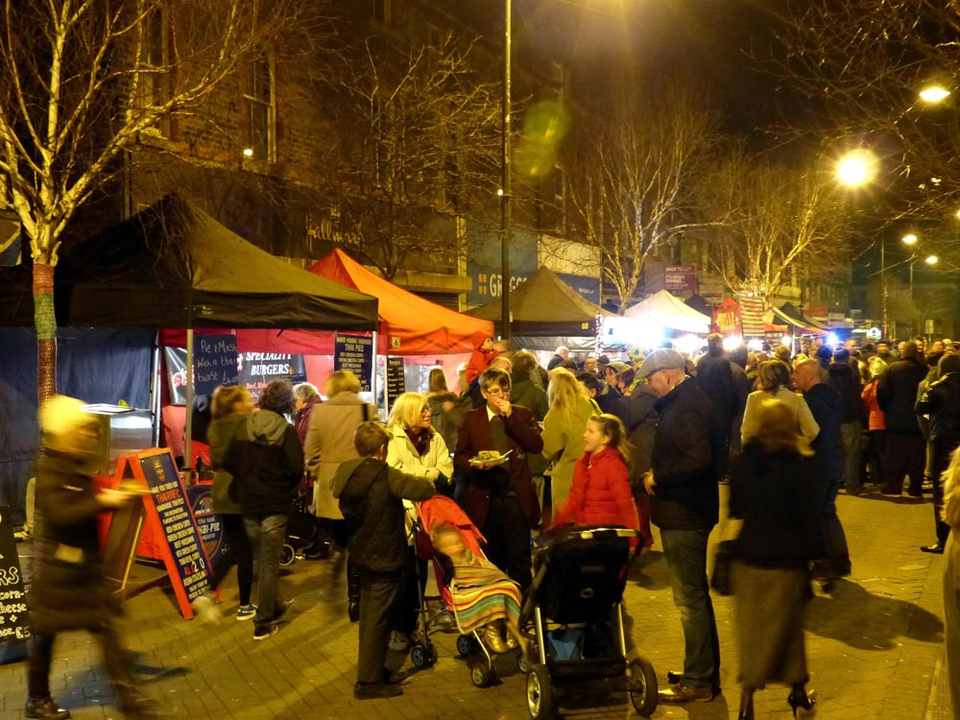

Reference

Norman Caesar. (2014, February 27). Street food event Crosby Village. Geograph Britain and Ireland. https://commons.wikimedia.org/w/index.php?curid=123607576

Within the creative commons the below referencing weas used. I was not easily able to relocate the image to reference for the use in the CRAAP evaluation activity.

[[File:Street food event Crosby Village - geograph.org.uk - 3868343.jpg|Street_food_event_Crosby_Village_-_geograph.org.uk_-_3868343]]
Street food event Crosby Village - geograph.org.uk - 3868343.jpg

Describe how your selection would support learners’ understanding of an element or concept for a course.
My search began with a focus on busy events. In teaching an events class I found interest in locating such an image; the image will be used to question the students understanding of what needs to occur before the planning begins. I feel this question will expose prior knowledge.
Summarize your search strategy (use of keywords, Boolean search operators).
I used Booleans; the Booleans used were busy AND event and community.
Does this image incorporate diversity and inclusion?
I feel the image would be better serving is it included further diversity in event participants. I feel this could lead to another engaging conversation with students.
I could ask:
Does the image include representation of the potential participants? Why or why not?

