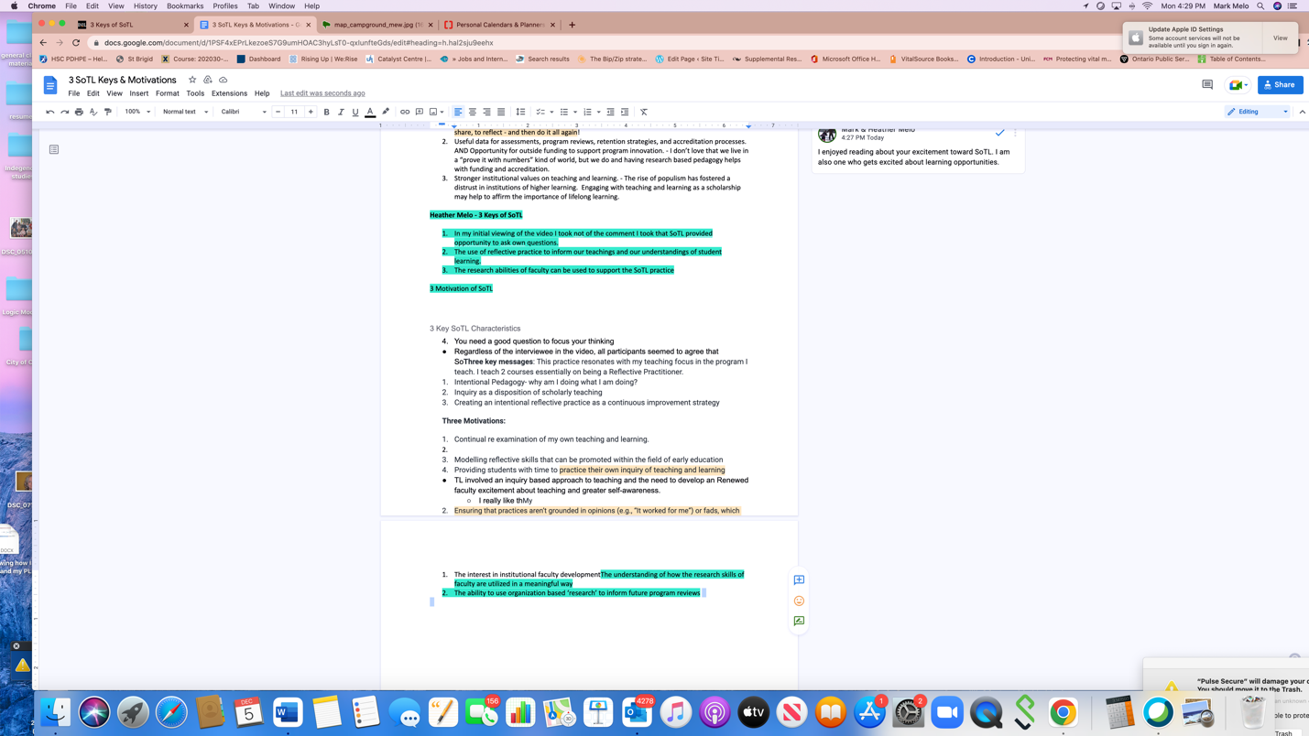

I have used blue highlighting to show where my content is located. I could not seem to keep the content together. I feel that the separating post may have been added as a footer.

Heather

