To Do:
Upload a screenshot of your contributions to the google doc as evidence of completion.
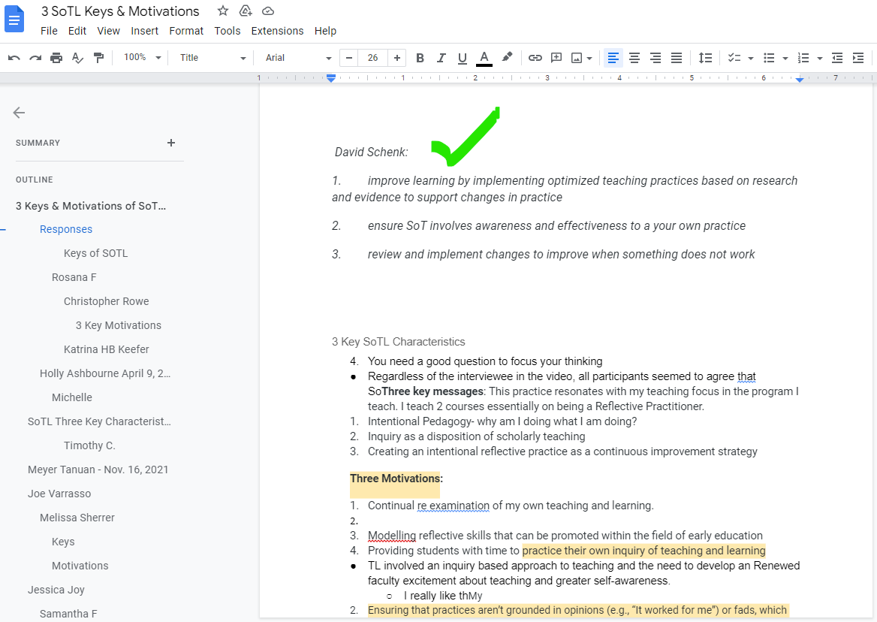
David Schenk:
- improve learning by implementing optimized teaching practices based on research and evidence to support changes in practice
- ensure SoT involves an awareness and effectiveness to a your own practice
- review and implement changes to improve when something does not work

Outcome
Create an action plan to examine key questions about improving learning outcomes in a specific discipline area using your own professional practice, informed by the research of others, to build your SoTL plan.

Objectives
- Explore key characteristics of SoTL.>> “scholarship of teaching and learning” (SoTL), involves an awareness and effectiveness to a your own practice. The purpose of SoTL is to improve learning by implementing optimized teaching practices based on research and evidence to support changes in practice
- Identify instructional practices or teaching strategies from your own discipline that you would like to explore or test within your own courses.>> Bring in guest lecturers that have experience with the lesson or topic
- Consider what pre-existing instructional practices or teaching strategies from your own discipline potentially create limitations and barriers for students with varying experiences. >> many students get focused on theory for grades and forget about applying this knowledge in real market situations. Having guest speakers will change this and enhance the effectiveness and learning experience
- Identify a range of research strategies that suit your discipline. >> Harvard has conducted much research and currently uses ‘case study’ teaching methods
- Identify a framework for analysis of your research. >> Analysis would be if this style of teaching helps students prepare and obtain jobs
- Select a strategy for sharing your research for others to build on. >> The strategy to focus research is methods that SoTL improve learning (eg. implementing optimized teaching practices based on research and evidence to support changes in practice).

What keeps you going? What motivates you? We’ve provided a list that describes potential benefits to help motivate you to become more engaged in SoTL activities, the WIIFM value! Reflect upon the things that make you love teaching and complete the following activity.

To Do:
From the list of potential benefits above, pick the top three statements that would motivate you to become more engaged in SoTL activities. You might also consider benefits not included on the list.
- Useful data for assessments, program reviews, retention strategies, and accreditation processes.
- Faculty development opportunities.
- Opportunity for outside funding to support program innovation.

To Do:
- Update the SoTL plan to include considerations of any ethical concerns with the research you are planning.
- Share the link or upload the latest version of your SoTL plan as your response for this activity.
- After you make your submission, save the web address to your response (found in the green confirmation box) so you can use it later for your badge submission form.

Plan for a SoTL Project
by David Schenk, Conestoga College

Research Question
What are you curious about? >> How subject matter experts as guest speakers enhance the learning outcomes of students

What would you like to know about strategies that might hinder and/or help students to learn, in your course? >> How a guest speaker helps them learn

Do you want to know if an activity, assignment, or teaching strategy “works?”>> Yes..the strategy above

Do you have a question about how to help your students learn a particular skill? >> How do help students take what they have learned form a guest speaker and apply to real work situations

Identify challenge/outcome related to learning that is related to your question.
Describe the learning in a way that suggests how you might measure it using either qualitative or quantitative methods. >> you can measure with a pre and post class survey with the students
Describe the instructional activity, assignment, or teaching strategy that will promote student learning on the outcome you identified.
SoTL projects might investigate the impact of a modification to an existing strategy or assignment. Describe how the new approach differs from the old approach and why this modification might change student learning on this outcome. >> The activity of a pre and post survey asking students about the effectiveness of the guest speaker will provide a measurement and suggestions for future improvements if any.
Describe the evidence that would persuade an external audience that the new or modified teaching strategy improves student learning on the targeted learning outcome.
Describe the evidence you would need to collect to answer questions about the impact or value of this teaching strategy. How would you convince others that this approach is better than other approaches? What comparisons should you make? Examine students; skill before and after the assignment? Compare students who complete the learning activity to another group of students – what comparisons would be meaningful? >> Evidence would be a survey from students from a class before this activity was implemented and after. The survey would be ‘How comfortable are you about applying or entering the workforce’
How and where would you publish, present, or disseminate this work? >> School websites (professional development), and teaching / educational websites.

Regards,
David Schenk
Conestoga College Instructor
dschenk@conestogac.on.ca

