Extend Activity #1

Collaborative Dining Table
By David Schenk Feb 27 2023

- Find an openly licensed image of a dining table on Unsplash, Pixabay or Creative Commons
- Select an Image editing tool in the Extend Toolkit or one you are familiar with, to begin modifying the image you have selected.
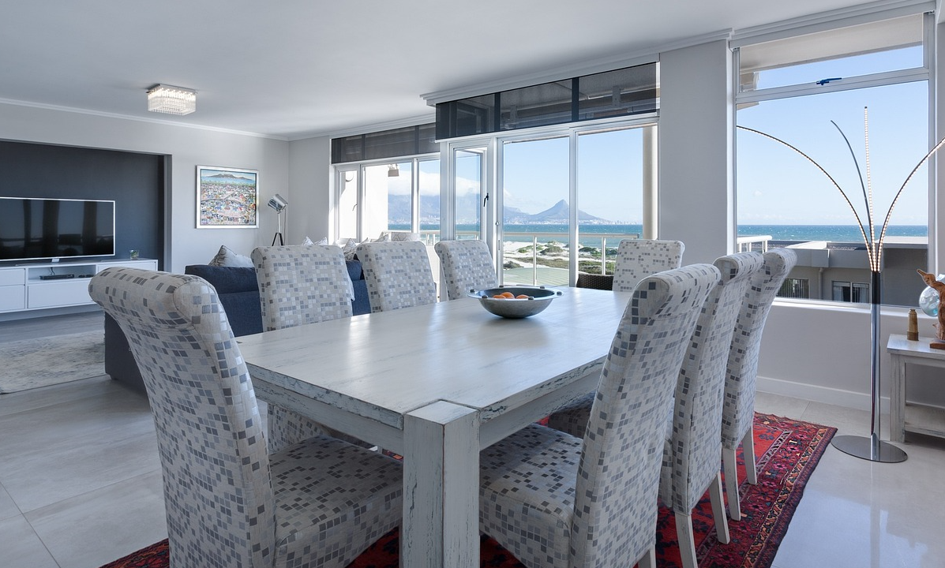.
Instructor
Team member #2
David
Verbal (in person), sheet of paper on the table
Team member #1
Team member #3
- Choose one of the projects you identified (successful or otherwise) and using the image editing application, add each person’s name as a place setting at the table (you do not have to put real names). >> Project : BOPPPS for a lesson
- Describe each person you worked with. Consider the following questions:
  - Were they part of or outside of your discipline? >> outside and inside (the course we took had both)
  - How did your skills compare with theirs? >> similar disciplines (eg business) had similar skills / methods
  - Do they offer a diverse perspective that is different from yours? If so, how does this help improve your teaching? >> The ‘outside discipline’ members (eg engineers) had different perspectives that help shed light on other methods
- At the centre of the table add the modes and communication tools you used to collaborate. Note which ones worked better than others. >> verbal worked best since we were in person and could quickly refine and exchange ideas
- Identify patterns and gaps:
  - Highlight the type of people and processes that you know work well for you and which ones do not. >> team members from the same discipline (business) worked best since we had similar teaching methods and education
  - Identify anything that is missing from the table—anything you need to consider for future collaborations. >> The instructor helped keep things in check
- Take a photo or screenshot of your “collaborative dining table” or export it as an image file. >> image is above
- Share it on twitter with a mention of @ontarioextend and the hashtag #oextend. (Note: if you do not want to use Twitter you can submit the image file)> image file above (I am not on twitter)
- Your submission for this activity can be an uploaded image of your dining table image or add a link to your tweet @ontarioextend #oextend that includes the image.> image file above (I am not on twitter)
- After you make your submission, save the web address to your response (found in the green confirmation box) so you can use it later for your badge submission form.

