Extend Activity #3

Cultivate your PLN

I don’t use twitter. I find Linkedin is a professional platform to share PLN’s
- find a creative visual way to showcase/illustrate which new professional groups or new individuals align most to your professional interests.

>> Linkedin page attached (professors):
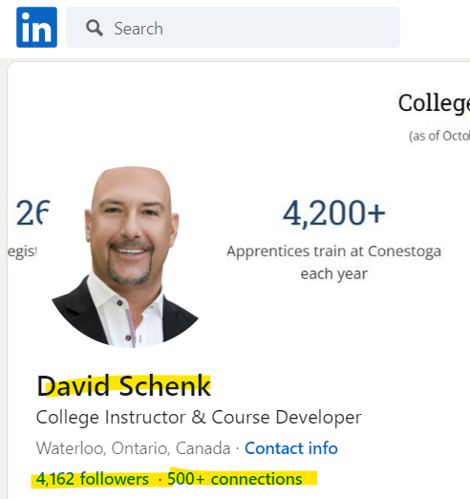
https://www.linkedin.com/in/david-schenk-b1288673/
