Extend Activity #4

Mapping your PLN

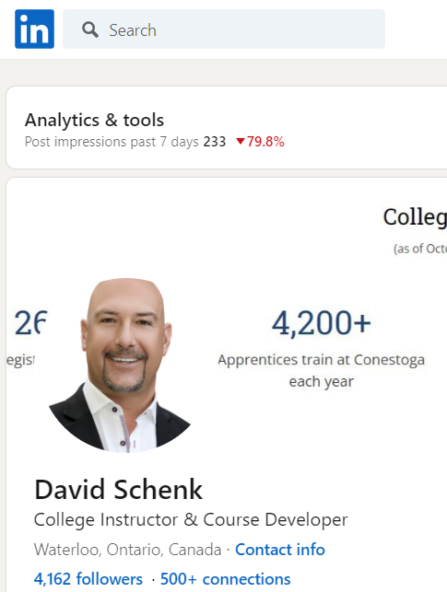
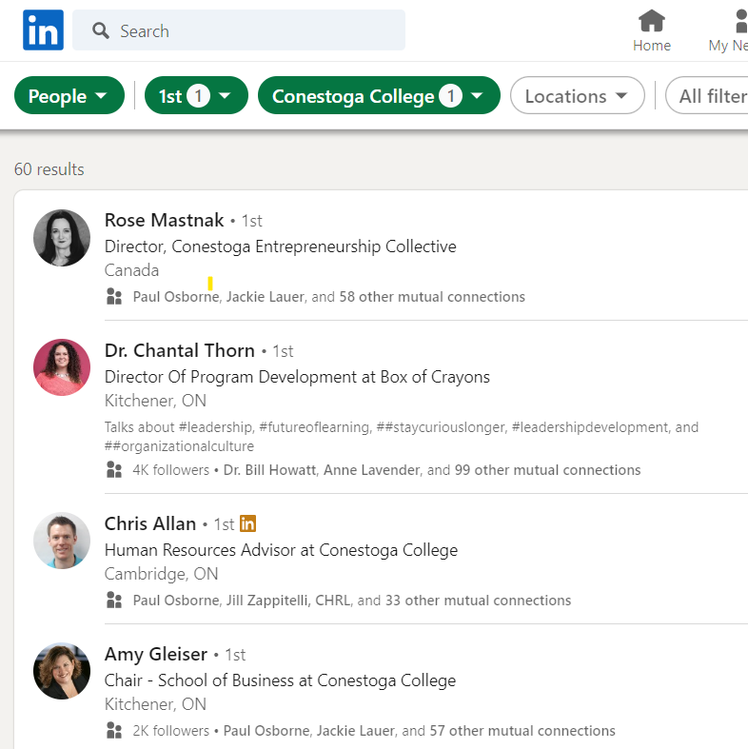

- Identify a focus of your PLN. >> Conestoga college

- Place your topic somewhere on your map. >> academic advancement

- Identify a few people who already belong to your network as it relates to your interest or topic. >> Conestoga professor colleagues on Linkedin (excerpt above)

- Think of a few more nodes that you may not yet know personally but who you would like to include in your network and add those nodes. >> similar colleges (Mohawk)
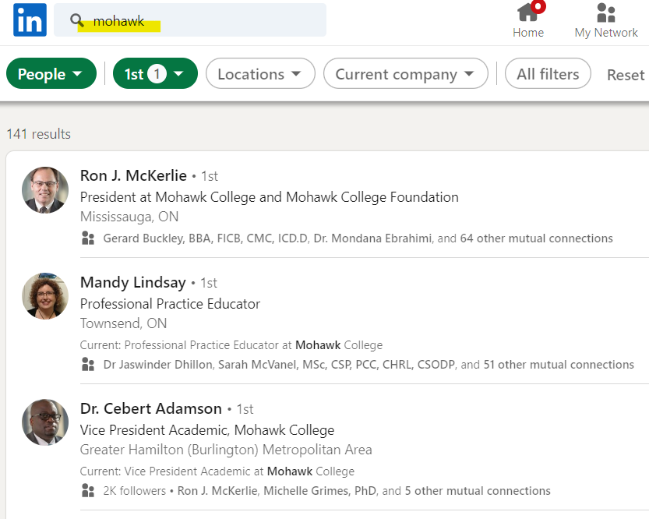Map the nodes (names) that you’ve identified onto your diagram. (see above)

