Plan for a SoTL Project
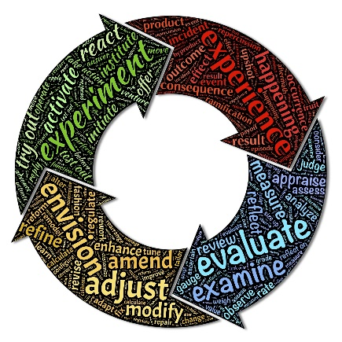
by Valerie McQueen, Fleming College
Research Question
What are you curious about?
What would you like to know about strategies that might hinder and/or help students to learn, in your course?
Do you want to know if an activity, assignment, or teaching strategy “works?”
Do you have a question about how to help your students learn a particular skill?
I am very curious about how students draw connections between the assignments we’ve given them and the program’s core content. Are they drawing the connections? Can they understand why we chose the assignment to meet the learning outcome? It might be hard for a student to dig deep into an assignment without fully understanding the why, and they may not focus their attention on the most important aspects for them.
I will focus my research on understanding what, from the student’s perspective, they’ve learned from an assignment rather than on what we expect them to learn. I’ll be able to use that to support making changes as required.
Identify challenge/outcome related to learning that is related to your question.
Describe the learning in a way that suggests how you might measure it using either qualitative or quantitative methods.
The challenges that I see here are in understanding the student’s perspective. I will put together surveys using MS Forms. These will include both quantitative and qualitative questions about their feelings on the assignment and what they felt they’ve learned. I will be very careful not to include any leading questions. The difficulty may be in getting the students to complete the survey. I’ll focus on what’s in it for them. I value their opinions and would be letting them know that this would be used to improve the course.
Ethical Concerns:

First and foremost, to address here is the power imbalance. For the research to be ethical, there must be a way of addressing that imbalance. Anonymity would be one way, but given that the classes are only 40 students, the iterations would have to be adapted to be longer. The easiest thing to do would be to have the data be returned anonymously at the end of the semester once students have received their grades.
One thing that would be very important to
Describe the instructional activity, assignment, or teaching strategy that will promote student learning on the outcome you identified.
SoTL projects might investigate the impact of a modification to an existing strategy or assignment. Describe how the new approach differs from the old approach and why this modification might change student learning on this outcome.
Between when students are given a case study and when we take it up in class, rather than only have them do their analysis, I would ask them to complete a survey on what they believe their focus is on the assignment. I’d follow that up with a second question once we’ve taken up the work in class, as that is where I would be drawing a lot of the links prior to their final assignment. By staging this, I would be able to see whether there is any progression in the responses.
The modified teaching strategy would have to be evidence based. I would look to use the information provided to adjust either the cases given, or the lectures associated with the seminar in order to be more specific if need be. This would be documented beforehand, but only once results are collected.

Describe the evidence that would persuade an external audience that the new or modified teaching strategy improves student learning on the targeted learning outcome.
Describe the evidence you would need to collect to answer questions about the impact or value of this teaching strategy. How would you convince others that this approach is better than other approaches? What comparisons should you make? Examine students; skill before and after the assignment? Compare students who complete the learning activity to another group of students – what comparisons would be meaningful?

I believe the evidence here would show up in the weekly quizzes. Have the students understood the concepts, and can they relate them outside of the case study? I could compare it with earlier in the semester.
How and where would you publish, present, or disseminate this work?
I would share this in a department meeting.

Adapted from: C. J. Stanny, E. M. El-Sheikh, & H-M. Chung (2009) Getting Started with a SoTL Project
Center for University Teaching, Learning, and Assessment http://uwf.edu/cutla/

