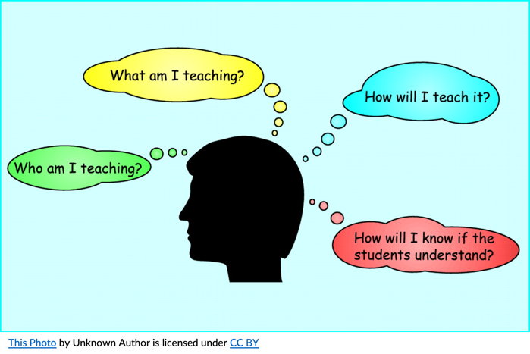
Like Driving a Car - Lesson Planning

Although planning a lesson may seem simple to those who have years of experience in instructional design, it is a process that requires a lot of knowledge and skill in a multitude of areas. Planners need to know the underlying requirements of evidence-based lesson planning: UDL, Principles of Adult Learning, Differentiated Instruction, Assessment, among others. They also need to know how to identify learning outcomes and competencies and decide on the sequence in which these are to be addressed. They need to know what students must know and be able to do to accomplish these. Below is a simplified lesson plan that identifies some of the requisite knowledge and skills involved. Lesson planning requires knowledge and skill in designing 4 stage lesson plans. Each of these stages require specific knowledge and skills.

4 stages of the lesson cycle
- Minds On, Connection – in this stage, the goal is to access prior knowledge of the topic so that students will be able to integrate this with new knowledge to be presented. This is the stage in which we can respond to the WIIFM questions. Lesson planners would need to know what prior knowledge means, how to access it, the importance of accessing prior knowledge and respecting students’ lived experiences.
- New Knowledge/Teaching – in this stage course content or new knowledge is delivered. This should be done in manageable chunks and in a variety of ways. In this phase, planners would need to know their subject matter, their students, and UDL. They would need to know a variety of teaching strategies they could draw from to ensure that lessons were designed with UDL in mind.
- Practice/Interaction – in this stage, students explore and interact with the knowledge they have gained, braiding it in with their prior knowledge. This is the application phase of the lesson. In this stage, planners would need to know effective application strategies they could have their students participate in. If teaching adults, they would also need to know the principles of adult learning.
- Consolidation/Summary/Assessment – in this stage students reflect on their learning and activities, reviewing what they learned and identifying any questions they have that remain unanswered. How does this new learning make a difference in their lives? In this stage, planners would need to know how to guide reflection and consolidation in order to maximize understanding and consolidation. They would also need to know authentic assessment strategies.

References used:

Curriculum Development Guide, FNTI Curriculum Development Team
The Jumpstart Model. (n.d.). CTL. https://durhamcollege.ca/ctl/teaching/planning-to-teach/jumpstart-model/

