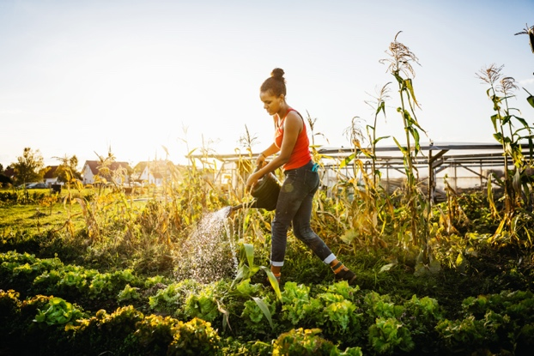Metaphor Activity

I think the metaphor for teaching and learning that resonates most with me is that of the gardener. My goal is to assist others in cultivating their mind, body and spirit by providing them with nourishment, a safe and secure environment, and personal space to grow in the ways they were meant to. Each student has their own strengths and needs, requiring different types of support, nourishment, and environment. It is the gardener’s duty to provide each plant with the things it needs, just as it is the teacher’s responsibility to provide each student with the resources they need to learn, flourish, and grow. Just as gardeners remove weeds that may hamper plant growth, so too do teachers help remove obstacles that may be in the path of student learning – whether they be physical, intellectual, emotional, or spiritual in nature.