Misunderstood Concept

- My mathematics students seem to confuse the x and y axes in linear graphing and are unsure how to plot the ordered pairs. Perhaps one analogy I can give to the students is you first need to get to the elevator before you can ride it. That means you need to walk/roll to the elevator horizontally before you can ride it vertically. This is how we graph; first we write down our horizontal unit and move across the graph, then we write down the vertical unit and move up or down the graph.
- Let’s talk about graphing – how do we know where to put our next ordered pair on the graph? Do we go left/right or up/down first? Let’s talk about the alphabet and elevators. In math, we write things out alphabetically just like we did in our last unit of algebra. The same is true here; we write down our x variable first and then our y variable. Similarly, we plot the ordered pairs like that as well – find the value on the x-axis and then the value on the y-axis. This is kind of like how we take elevator rides; first we need to get to the elevator – so we need to walk or roll there turning left and right as needed. Then when we get to the elevator we can then go up or down as needed. The getting to the elevator is our turning left or right on the x-axis. Then riding the elevator is us going up or down as needed to make it to our destination (the ordered pair). You can’t ride the elevator until you are in the elevator.

NanaYawBotar, CC BY-SA 4.0 <https://creativecommons.org/licenses/by-sa/4.0>, via Wikimedia Commons
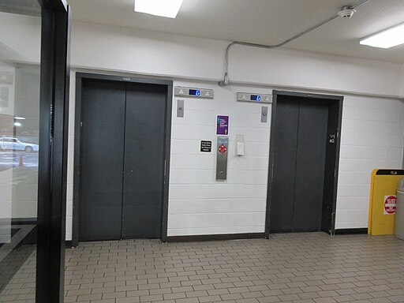
Information of New Orleans, CC BY-SA 4.0 <https://creativecommons.org/licenses/by-sa/4.0>, via Wikimedia Commons

