Thought Vectors and Nuggets – Patch Twenty-Four: It’s not so scary to walk the walk

When I read this passage, I thought that it sounded a lot like the way I like to think of trying out new things. Here is the last paragraph that really resonated with me: I need to learn what resources and skills I need to create an effective and accessible assignment. And I need patience, as demonstrated by the suspicion that I see multiple “takes” in my future as I learn how to develop this type of assignment. It will be an evolving process, and I hope that as my students see me learn from mistakes that they’ll be willing to take risks and share in ways they feel comfortable with. Where will it go? Well, I’m making my own learning visible, too, and you can check it out at: https://juliemoser.tumblr.com/”

I teach in the Pre-Health Sciences program, which means the students I have are there to learn the basic sciences and communication concepts so that they can do well in their next program. My students are applying to Life or Health Sciences programs after the first semester of my teaching, and they learn whether they’ve gotten into the next program by the time I’m done teaching them their second (and final) semester. My students are mature students, and students that either didn’t have the science background or grades required to get into their desired program. This means, when I’m designing an assignment, I need to think about whether my students would be able to complete the assignment, and learn the information I want them to. I teach math, and I tell my students that you don’t learn from the mistakes you don’t make, so try your best with the homework and assignments and learn not to make those same mistakes again. This is the same type of strategy I use when creating assignments.

The assignments used to be group assignments in class with a 50-minute time limit, where I had assigned them to a different group each time to get them to talk to other people. This was too stressful for the students as they didn’t like to talk to new people, and they didn’t like the time limit. So I kept modifying these assignments every year to finally get them to a point where I think they’re really learning the material and they’re doing so much better in the course. Instead of having the assignments as an in-class activity, I’ve put them online for easier access. I’ve learned how to make the assignments more accessible by utilizing the external learning tool Pearson MyLab, which can use a screen reader to ask them the questions for students with accommodations. I’ve learned to give them two attempts at each assignment, as they tend to try to rush through it the first time and end up making lots of little mistakes, as I have very explicit instructions for formatting their answer that they often don’t pay attention to the first time. I have learned to make these assignments open book and give them a whole week to finish them. They can work together; however, each student must submit their own assignment for individual feedback and grading. The assignments are assigned using an algorithm that gives each student a different question – same concept but different numbers or asked in a different way. I have made these changes bit by bit and see that the students are happier each year and they end up doing much better with learning the material. I will remember to keep an open mind and try new things to see if it helps the learning process, and if it doesn’t, I can try something new the next time.

Here are examples of the assignments before and after:
BEFORE
/40
ASSIGNMENT #2 – Fractions
Before you start, list the names of group members in the spaces provided below. Each group member must sign next to their name to acknowledge their contribution to the assignment.
- Name: _________________________________ Signature:
- Name: _________________________________ Signature:
- Name: _________________________________ Signature:
- Name: _________________________________ Signature:
- Name: _________________________________ Signature:
The assignment consists of three sections, containing 12 questions worth a total of 40 marks.
SECTION 2 only: Each group member, as listed above, must be responsible for answering at least one question in this section. In order to validate this, the group member answering the question must initial in the space provided. Failure to do so will result in an automatic loss of 10 marks.

SECTION 1 – The Basics [15 marks]

- Using fraction notation, state what part of each object is shaded: [2 marks]

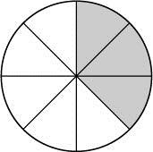
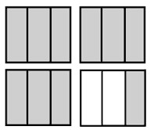
  - b)

- Simplify each of the following fractions and state your final answer in lowest terms: [3 marks]

a) $\frac{15}{18}$ = b) 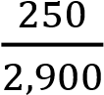 = c) 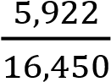 =

- Fill in the following blanks with either the > or < symbol: [3 marks]

a) ____ b) $\frac{6}{13}$ ____ $\frac{9}{20}$ c) 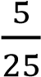 ____ 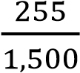

- State the reciprocal of the following fractions, and simplify if necessary: [3 marks]

a) = b) = c) 36=

- Multiply the following fractions, and state your final answer in lowest terms. [4 marks]

a) × = b) 6 × =

SECTION 2 – The Intermediates [20 marks]

1. Determine if the following fractions are equivalent by comparing the cross-products. Show all of your work for full marks. [4 marks]

a) and 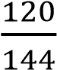 b) 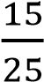 and 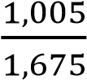

Initials □

2. Divide the following fractions, and state your final answer in lowest terms. [4 marks]

a) ÷ 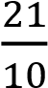 b) $\frac{4}{5}$ ÷ 6

Initials
□

3. Add the following fractions, and state your final answer in lowest terms. Show at least one step of your work. [6 marks]

a) 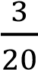 + 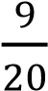 =

Initials

□ 
b)
$\frac{9}{15}+ \frac{3}{5}$ =

1 + + =

4. Subtract the following fractions, and state your final answer in lowest terms. Show at least one step of your work. [4 marks]

a) $\frac{15}{23}- \frac{12}{23}$

Initials

□

b) $12- \frac{2}{3}- \frac{5}{9}$

5. Solve the following equations for the given variable. [2 marks]

a) 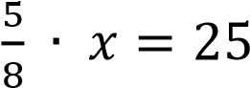 b) 𝑦 $\frac{9}{10}= \frac{1}{5}$

Initials

□

SECTION 3 – Tough Stuff [5 marks]

- A patient is to receive an IV infusion of 1,000 millilitres of normal saline over a period of 8 hours. A nurse checks on the patient after of the bag has been infused. How many milliliters of fluid has the patient received? How many hours have passed since the IV was started? Show your work and include a therefore statement for full marks. [3 marks]

- Solve the following equation for the given variable. Show at least one step. [2 marks]

AFTER
