Curation Creation Activity:
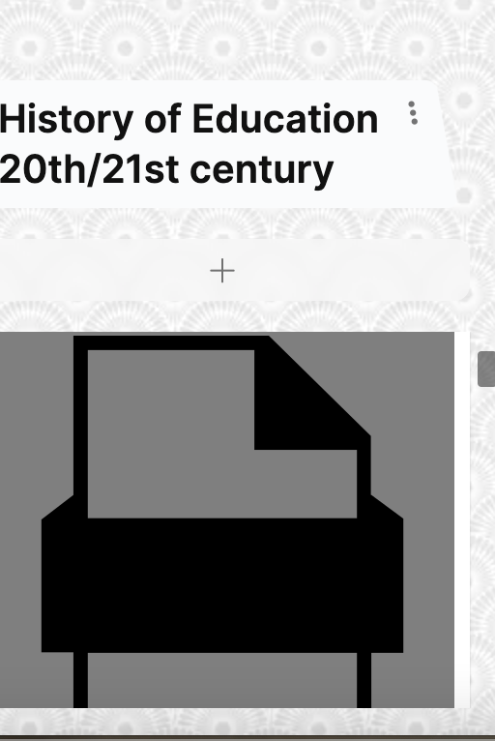

Links to padlet posts:

https://padlet.com/extend_ecampusontario/curation-as-creation-creation-as-curation-nis016u27mla/wish/2649874967

https://padlet.com/extend_ecampusontario/curation-as-creation-creation-as-curation-nis016u27mla/wish/2649873282

https://padlet.com/extend_ecampusontario/curation-as-creation-creation-as-curation-nis016u27mla/wish/2649872685

