# [Patch 30 – Engaging Students with Wikipedia](https://openfacultypatchbook.org/uncategorized/patch-thirty-engaging-students-with-wikipedia/) – May 17, 2019, By Dr. Kathleen Sheppard

## The nugget

Sheppard (2019) notes, “More importantly, for me as an instructor, they learned some skills. Research methods, including searching for and finding sources. Critically thinking about sources and stuff they read. Distilling information and writing about it in a clear and well-organized way. These skills will translate for all students much more than shoving a ton of information in their brains will. We want them to be good employees (ROI!!!!!), but also good, functional members of society who can think for themselves and know BS when they see it” (para. 27).

## Reflection

I came across this patch that discusses having students contribute to Wikipedia and something finally jumped out at me. I have been working extensively over the past few months to make my course more relevant, and address the issues that the rising availability of artificial intelligence (AI). I want to inspire my students to both recognize the downsides of these tools AND actually build their skills by trying my assignments, rather than just taking the easy way out.

The links between AI tools and and Wikipedia are now occurring to me. We’ve spent at least a couple of decades trying to remind students that Wikipedia is not necessarily a reliable source (though projects such as the one described in this patch can certainly help). We know that the AI tools train on whatever content they can get their hands on, which means they’ve trained on Wikipedia…. Which also means that whatever bias, errors, lack of representation and other issues are still sitting in Wikipedia are now feeding the AI tools. The systemic problems are amplified by AI tools.

I already talk to my students about how Wikipedia can be a useful tool (background research, mine for potential sources on topics, etc) and now that I’ve read this article, I want more and more to do something around identifying bias/errors/problems in AI generated text. I’d love to do a project where my students are engaged in improving Wikipedia, but I don’t know how successful that would be in a first semester course. It’s something to think about, for sure.

I’m intrigued and wondering how I can talk about both Wikipedia and AI and address some of these issues all in one semester, but on a level that my students will find meaningful.

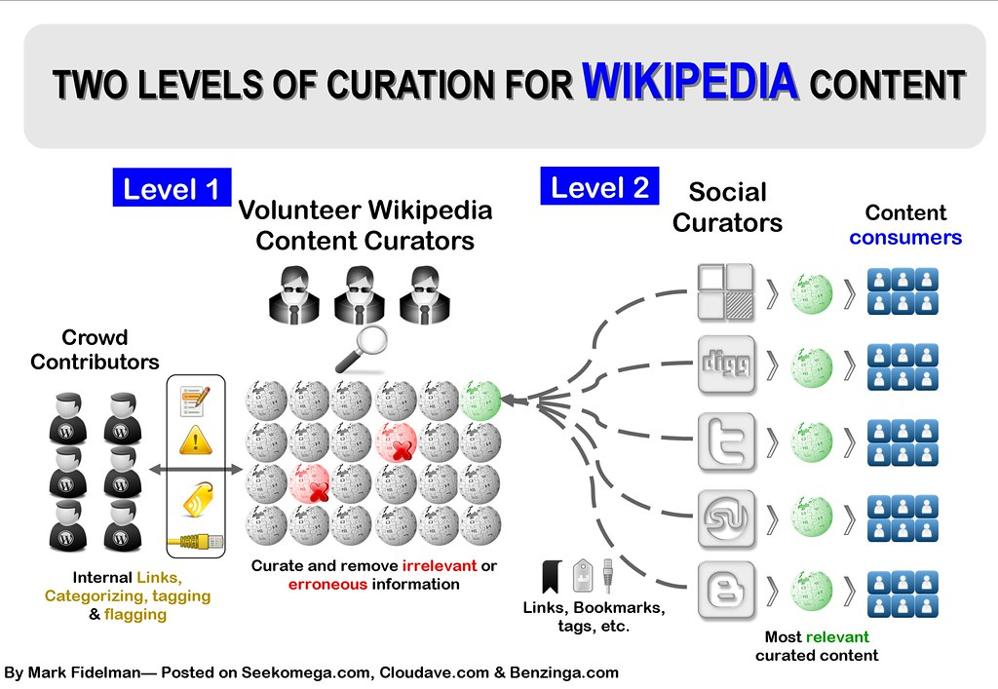  
**Image source:** "[Wikipedia Content Curation Infographic](https://www.flickr.com/photos/39372736@N04/4640722483)" by [Mark Fidelman](https://www.flickr.com/photos/39372736@N04) is licensed under [CC BY-NC 2.0](https://creativecommons.org/licenses/by-nc/2.0/?ref=openverse).

**References**

Sheppard, K. (2019, May 17). Patch 30 – Engaging students with Wikipedia. *The Open Faculty Patchbook*. https://openfacultypatchbook.org/uncategorized/patch-thirty-engaging-students-with-wikipedia/