# Searching for openly licensed images

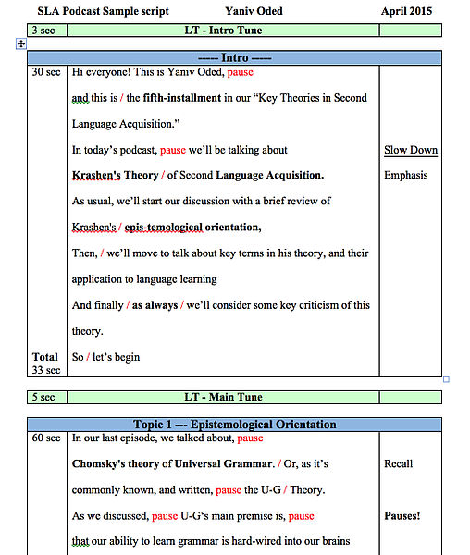

“[Script Sample](https://commons.wikimedia.org/wiki/File:ScriptSample.jpg)” by [Yaniv oded](https://commons.wikimedia.org/w/index.php?title=User:Yoded&action=edit&redlink=1), licensed under [CC BY-SA 4.0](https://creativecommons.org/licenses/by-sa/4.0/)

For my new podcast assignment (or podcast alternative to essay assignment), I want to incorporate some images that give students a feel for the assignment. All of the resources in the weeks leading up to the final informative research project are essay based at present, so I will need to integrate some podcast examples and resources to balance things out. I will be asking students to write and submit a podcast script, so this image will give them some ideas about what that might look like. While I’ll still need to develop out a text-version of a script for accessibility purposes, sometimes just having a visual image can help. That’s why I’ve selected this one.

Search strategy:

I almost always start with OpenVerse, because it provides attribution statements with every image it retrieves, but it really doesn’t always cast the net as widely as a google image search does, in some cases. For this particular search, I used Google.

“Podcast script sample” as the keywords is more than specific enough. I then limited to images, and then further limited to Creative Commons licensed materials. This image was the first one that popped up.

I did do some searching for an infographic about podcasting (podcast AND infographic) but wasn’t really finding much in the way of visuals that were openly licensed. I think I would rerun the search at intervals because eventually, there will be an infographic about this topic that will work well. For now, this still provides a bit of a visual so students can imagine what the script might look like.

This image doesn’t specifically support diversity and inclusion, as it’s just a screenshot of text. However, adding in user choice to the assignment does support diversity and inclusion, at least on a minor level.