Teaching and Learning Activity 7

I think my role as a teacher is to **guide** my students to develop a specific set of skills but also to learn about themselves, their potential, as well as their limitations. In other words, **guide them to explore** so that they find who they want to be and then help them develop the necessary skills to get there..

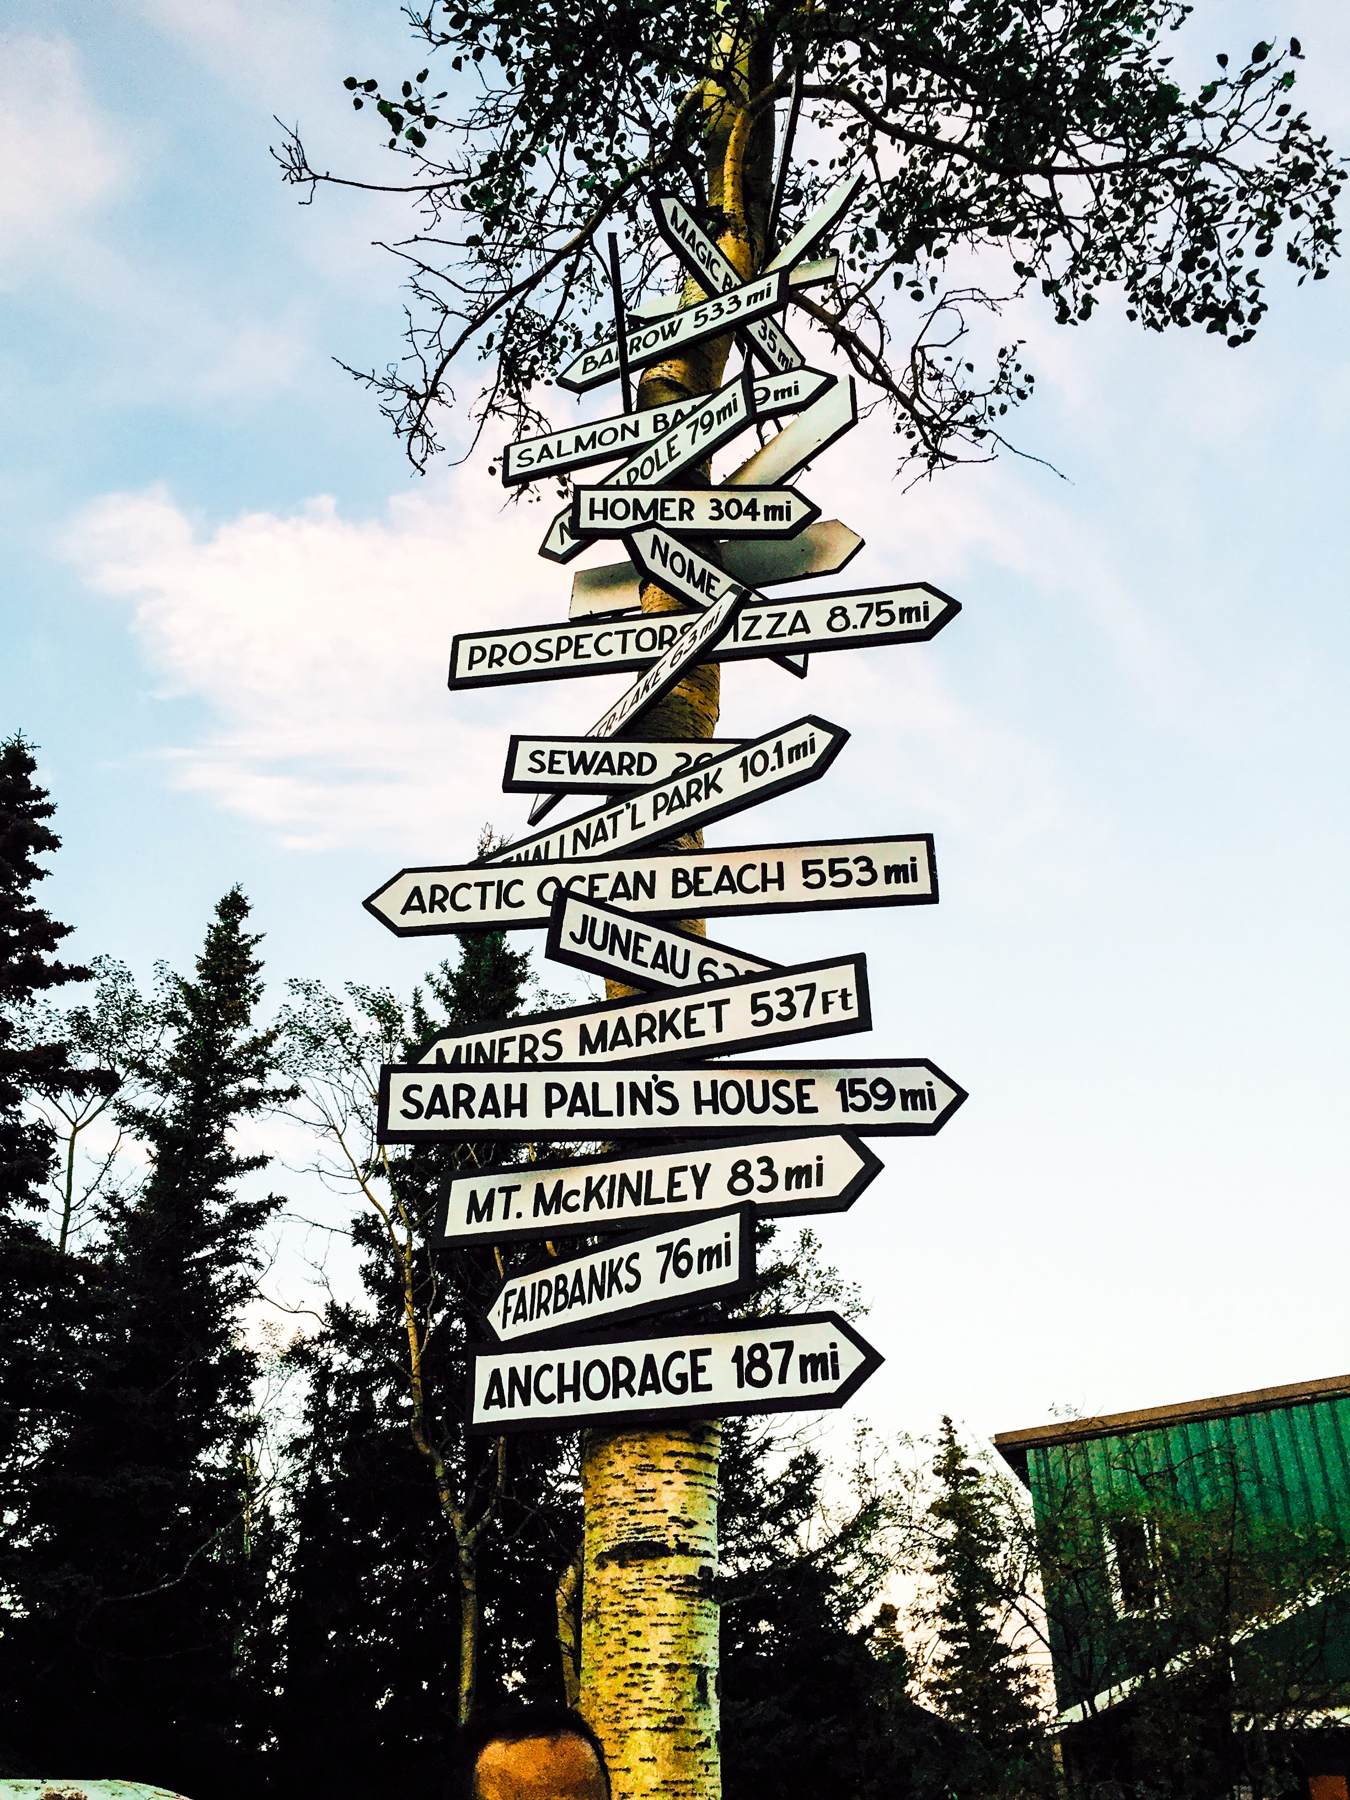

Photo by [Chandni Dan](https://unsplash.com/@moonshot2?utm_source=unsplash&utm_medium=referral&utm_content=creditCopyText) on [Unsplash](https://unsplash.com/s/photos/oportunity?utm_source=unsplash&utm_medium=referral&utm_content=creditCopyText)