**It’s Alive Activity: Zoom**

I am teaching a modular course. The delivery mode of this course is hybrid. In a week, students visit campus for 2 days for offline classes and for 2 days its online class. I have observed that students' attendance in Zoom classes is higher as compared to offline classes.

1. Include your process for **empathizing** with your learner

**Empathy map**

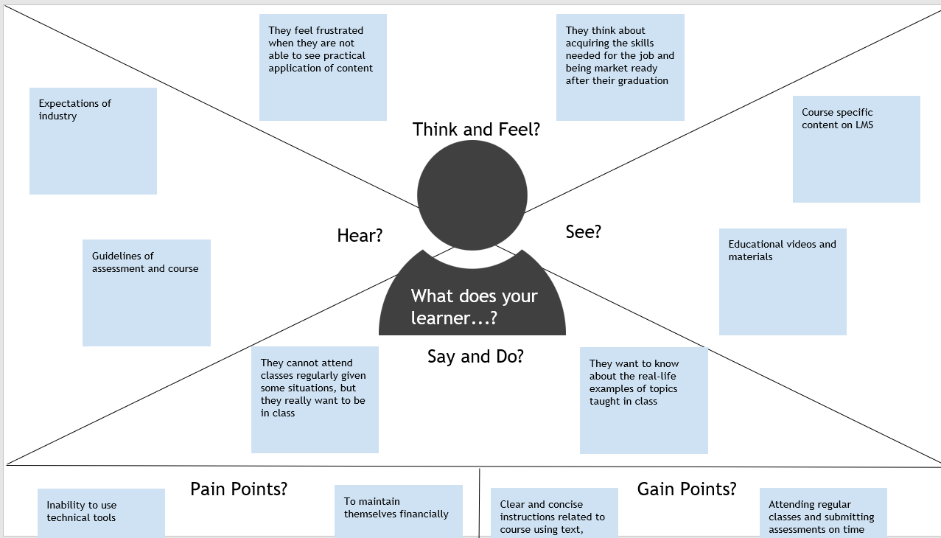

1. What you **defined as your learner challenge**

**Challenges**

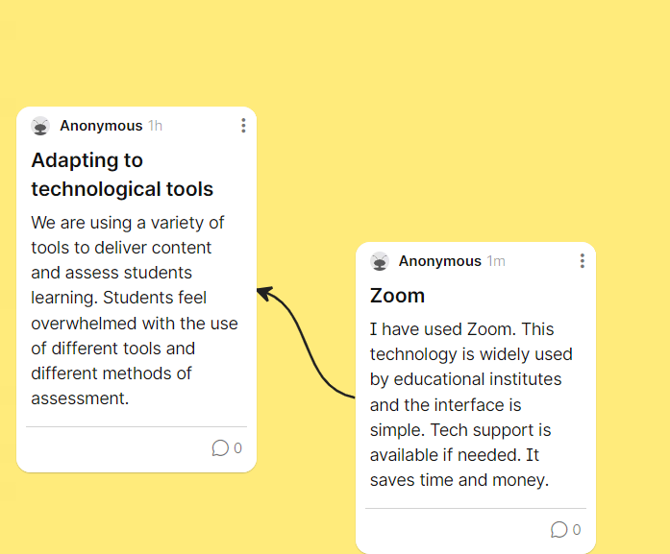

1. The steps you took in **ideating and prototyping** your technology creation

**Technology-Enabled Activity Planning Document**

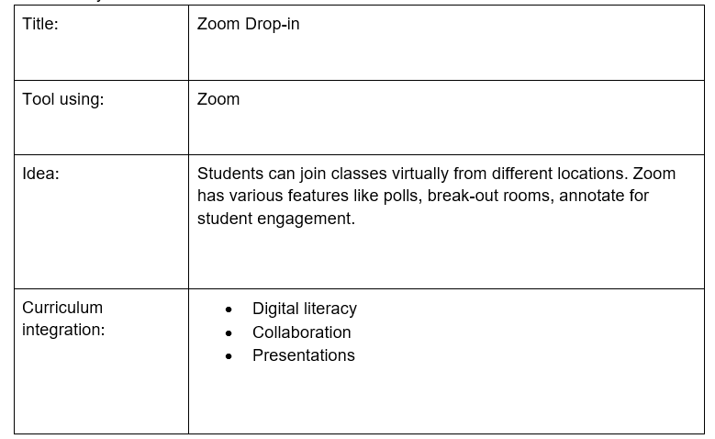

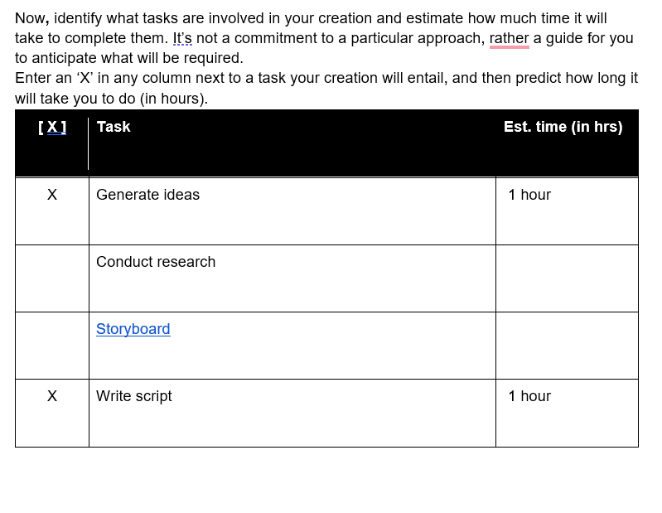

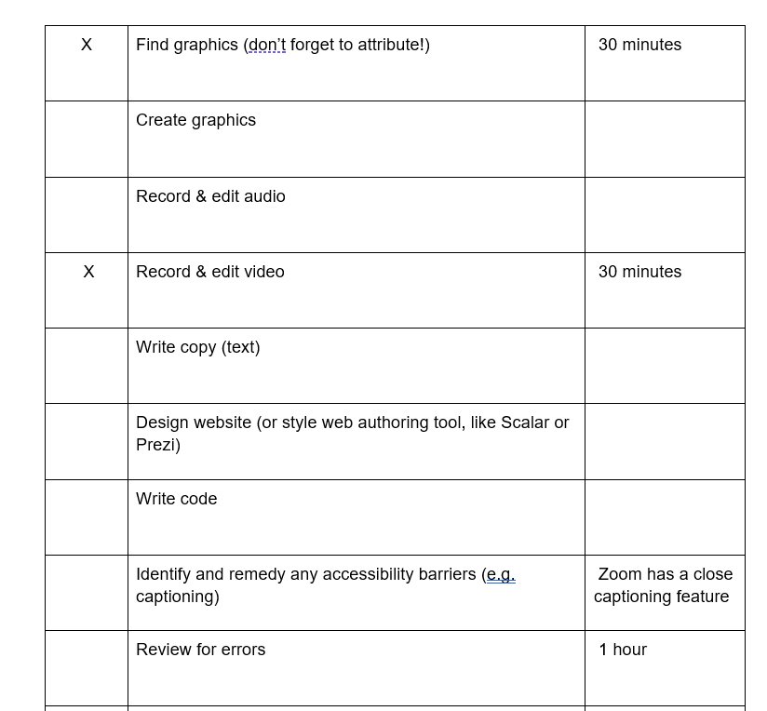

1. **Upload a screenshot** of your technology creation or **include a shareable link** if you completed your work online.

