Teaching Philosophy as a Nurturing Garden

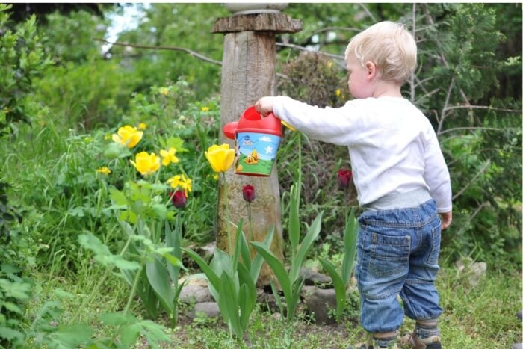
https://www.montessorinature.com/importance-benefits-gardening-children-toddlers-preschoolers/

I imagine my teaching philosophy as a nurturing garden, where each element symbolizes an essential aspect of the teaching philosophy:

Seeds of Knowledge: The seeds represent the information and knowledge. Just as a gardener carefully selects and plants seeds, I carefully select and deliver educational content to my students.

Soil of Experience: The soil in the garden represents the rich personal experiences of the students. Just as plants thrive in nutrient-rich soil,my students flourish when they can connect their own experiences to the course content.

Sunlight of Engagement: The sunlight represents the active engagement and participation of my students. Just as plants need sunlight to grow, my students require opportunities to actively engage with the material, challenge their own thinking, and refine their understanding.

Water of Reflection: Water is essential for a garden's growth, just as reflection is crucial for learning. Like providing water to nurture plants, I encourage my students to reflect on their experiences and previous interpretations, which allows them to grow and refine their understanding continuously.

Fertilizer of Theory: Just as a gardener uses fertilizer to enrich the soil, I incorporate nursing theories to enrich my teaching approach and ensuring that it's grounded in evidence-based practices.

Harvest of Understanding: The ultimate goal of my teaching philosophy is to help students harvest a deep and meaningful understanding of the subject matter. Just as a gardener reaps the rewards of a bountiful harvest, I am able to witness my students' growth and transformation as they gain insights and refine their understanding through experiential learning and reflection.

This metaphor represents my teaching philosophy because, like a skilled gardener, my role is to cultivate an environment where knowledge can take root, students can grow, and understanding can flourish.

