How to Study Homelessness?

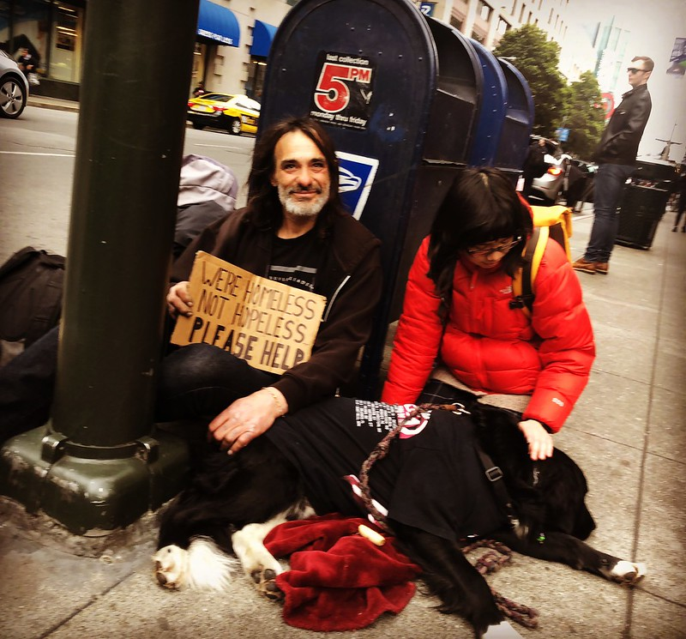
(Forbenius, 2018). CC BY 2.0 license

Until today, I primarily relied on Google Images to source visuals for my students' learning. However, during my recent search, I discovered the image described above through a Creative Commons Openverse search. I used the search terms "observation" and "homelessness," linking them with the Boolean operator "AND."

This image significantly enhances learners' comprehension of the concept of researching the lived experience of homelessness by providing a tangible real-world context. It serves as a catalyst for discussing the various data collection methods and empathetic approaches.

Furthermore, the image effectively exemplifies diversity and inclusion. It does so by depicting individuals from diverse racial and cultural backgrounds and by capturing their empathetic interaction. The message on the sign, "We're homeless not hopeless," underscores the significance of acknowledging the dignity and resilience of those experiencing homelessness. This image encourages an inclusive and compassionate perspective when investigating their lived experiences.

Reference

Forbenius. (2018, February 28). Life’s lessons are there for those whom can
observe. You don’t need gurus. “We’re homeless not hopeless” [Photograph]. Flickr. https://www.flickr.com/photos/35728723@N02/38675035200

