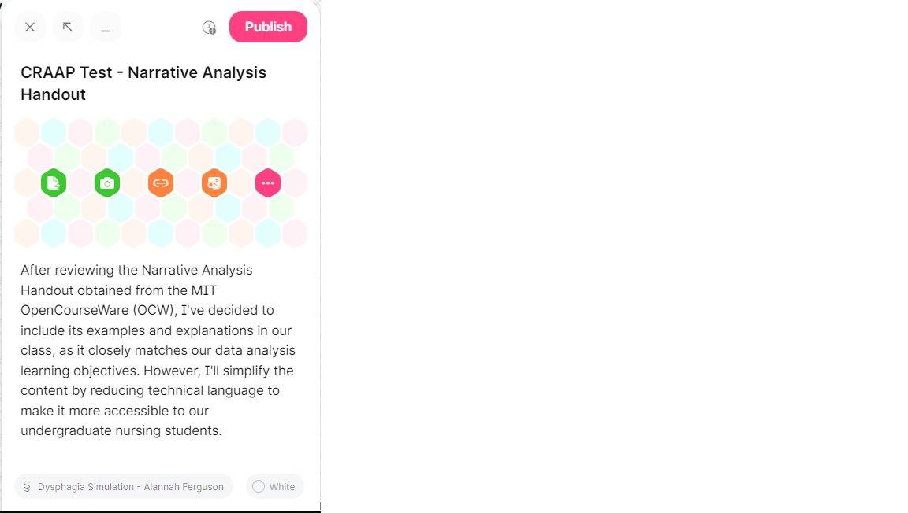

CRAAP Test
Resource Title:
Narrative Analysis Handout
Resource URL:
https://ocw.mit.edu/courses/11-237-practice-of-participatory-action-research-par-spring-2016/resources/mit11_237s16_narrative/
Currency: The timeliness of the information:
When was the resource published or posted?
Has the resource been revised or updated?
Does your topic require current information?
Are the links functional?
-The information comes from an MIT OpenCourseWare academic course last updated in 2016.
-Data analysis, as a field, doesn't demand real-time updates like rapidly evolving fields such as technology or medicine.
-The provided link is current and functional.
Relevance: The importance of the information for your needs
Does the resource relate to your needs?
Who is the intended audience?
Is the information in the resource at an appropriate level for your learners?
-The resource is part of an MIT OpenCourseWare course titled "Practice of Participatory Action Research (PAR)."
-This resource is intended for a more advanced academic audience, likely at the graduate level, rather than for undergraduate nursing students.
Authority: The source of the information
Who is the creator?
What are their credentials or organizational affiliations?
Are they qualified to write on this topic?
-Given Prof. Lawrence Susskind's recognized expertise in negotiation and dispute resolution and his affiliation with MIT, it is reasonable to conclude that he is well-qualified to write on topics related to narrative analysis, participatory action research, and related subjects.
Accuracy: The reliability and truthfulness of the information
Is the information supported by evidence?
Has the resource been reviewed or refereed?
Are there spelling, grammar, or typographical errors?
-The document is strongly supported by well-cited sources with Digital Object Identifiers (DOIs). It's worth noting that the majority of these sources are somewhat dated, typically falling within a range of 10 to 20 years old. Nevertheless, all the sources listed are peer-reviewed, and no spelling, grammar, or typographical errors have been identified.
Purpose: The reason the information exists
Why does this resource exist? (to inform, teach, sell, entertain, or persuade?)
Is the information fact, opinion, or propaganda?
Are there political, ideological, cultural, religious, institutional, or personal biases?
-The primary purpose of this resource is to inform and educate. It provides information on narrative analysis, its relevance in Participatory Action Research (PAR), various methods of narrative analysis, and when and how it should be used. The resource aims to educate individuals interested in PAR and qualitative research about the concepts and techniques of narrative analysis. It does not appear to be geared towards selling or entertaining, and while it may persuade readers of the value of narrative analysis in research, its primary function is educational.
-The information in the resource primarily presents facts and educational content about narrative analysis and its application in Participatory Action Research. It does not seem to promote a specific agenda or ideology. While some sections might include discussions on the strengths and limitations of different analysis methods, these discussions are generally based on the established principles of qualitative research rather than promoting a particular opinion or propaganda.
-The resource does not overtly exhibit political, ideological, cultural, religious, or personal biases. It appears to be a neutral educational resource intended to provide information about narrative analysis in the context of Participatory Action Research.
Notes: Are there additional questions or observations you have about this material that affect your decision to use it? (i.e. this is an opinion piece that I will use to demonstrate one side of an argument).
Final Recommendation: Will you use this resource? Why or why not?
-Having assessed the content of the Narrative Analysis Handout document, my intention is to integrate its examples and explanations into my class curriculum. This decision is based on its strong alignment with the class's learning objectives in the field of data analysis. However, I plan to make adjustments to the document by simplifying and minimizing the use of specialized terminology and jargon. This modification is aimed at ensuring that the content is both accessible and appropriate for our target audience of undergraduate nursing students.

