**It’s Alive – Technologist Final Submission**

**Empathy Map**

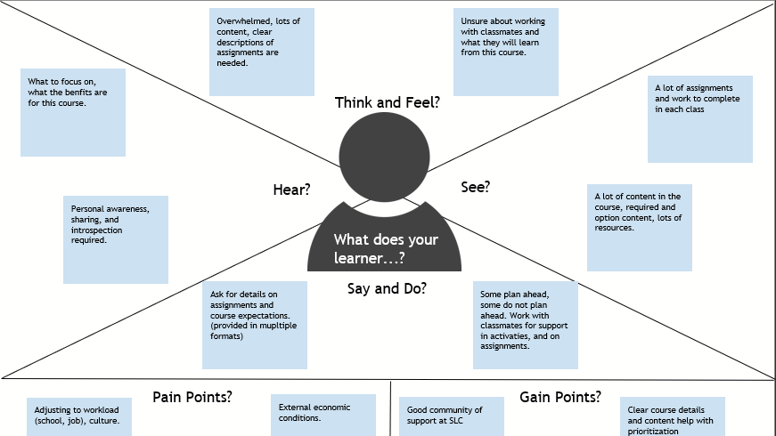

**Learner Challenge**

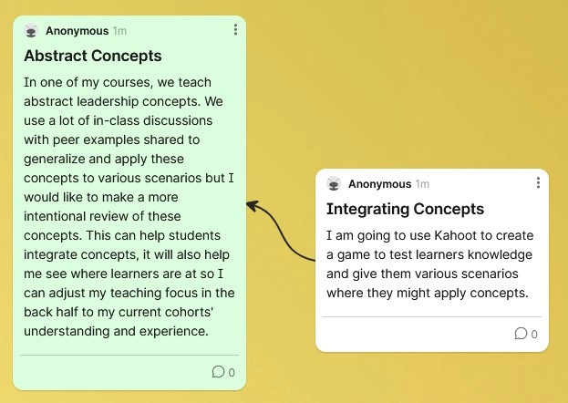

**Planned Implementation**

I will put this into practice next term and iterate as needed based on feedback from the class via open survey for feedback.

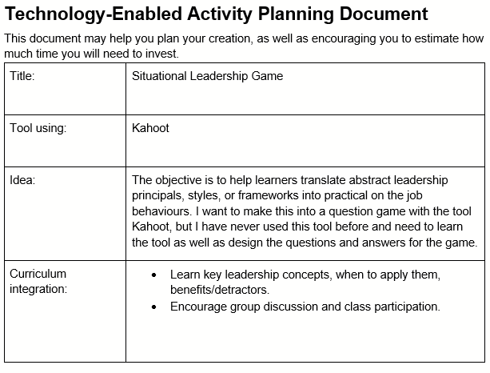

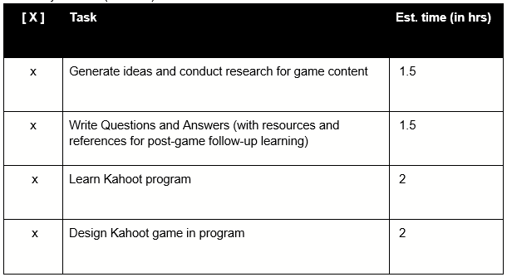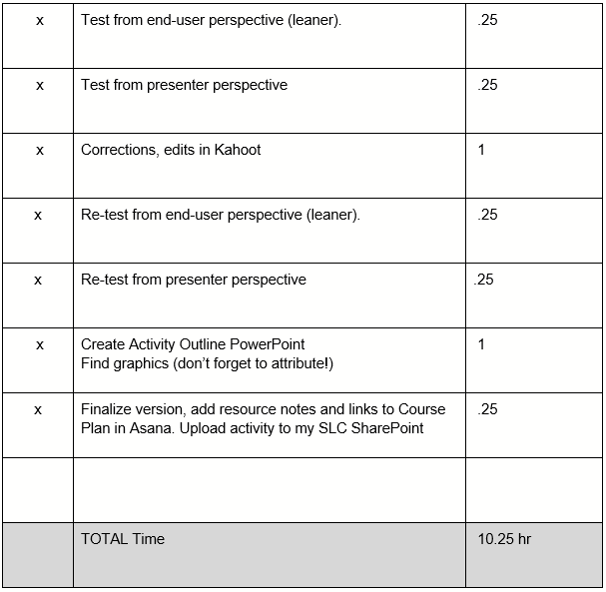

**The Game in Kahoot**

This quiz has 20 questions.

