Cornell Notes

Communications & Stakeholder Engagement

# **Your body language may shape who you are | Amy Cuddy**

# <https://www.youtube.com/watch?v=Ks-_Mh1QhMc>

Body Changes Our Mind; Body Language (TED Talks)

# Power Dynamics –

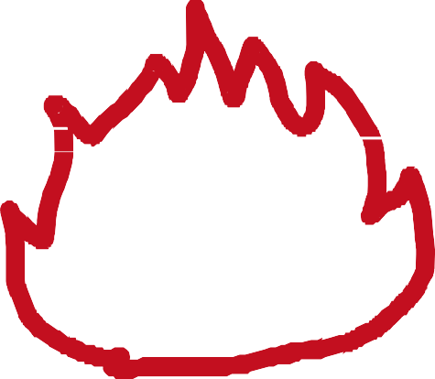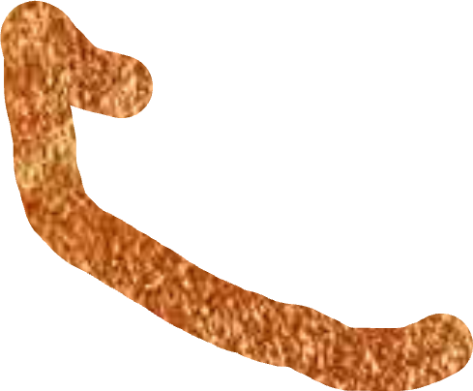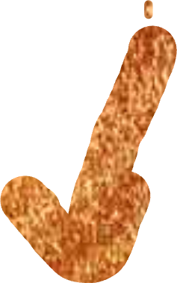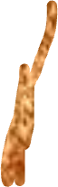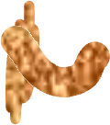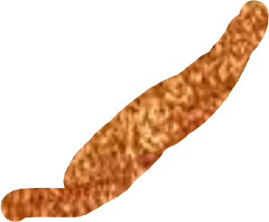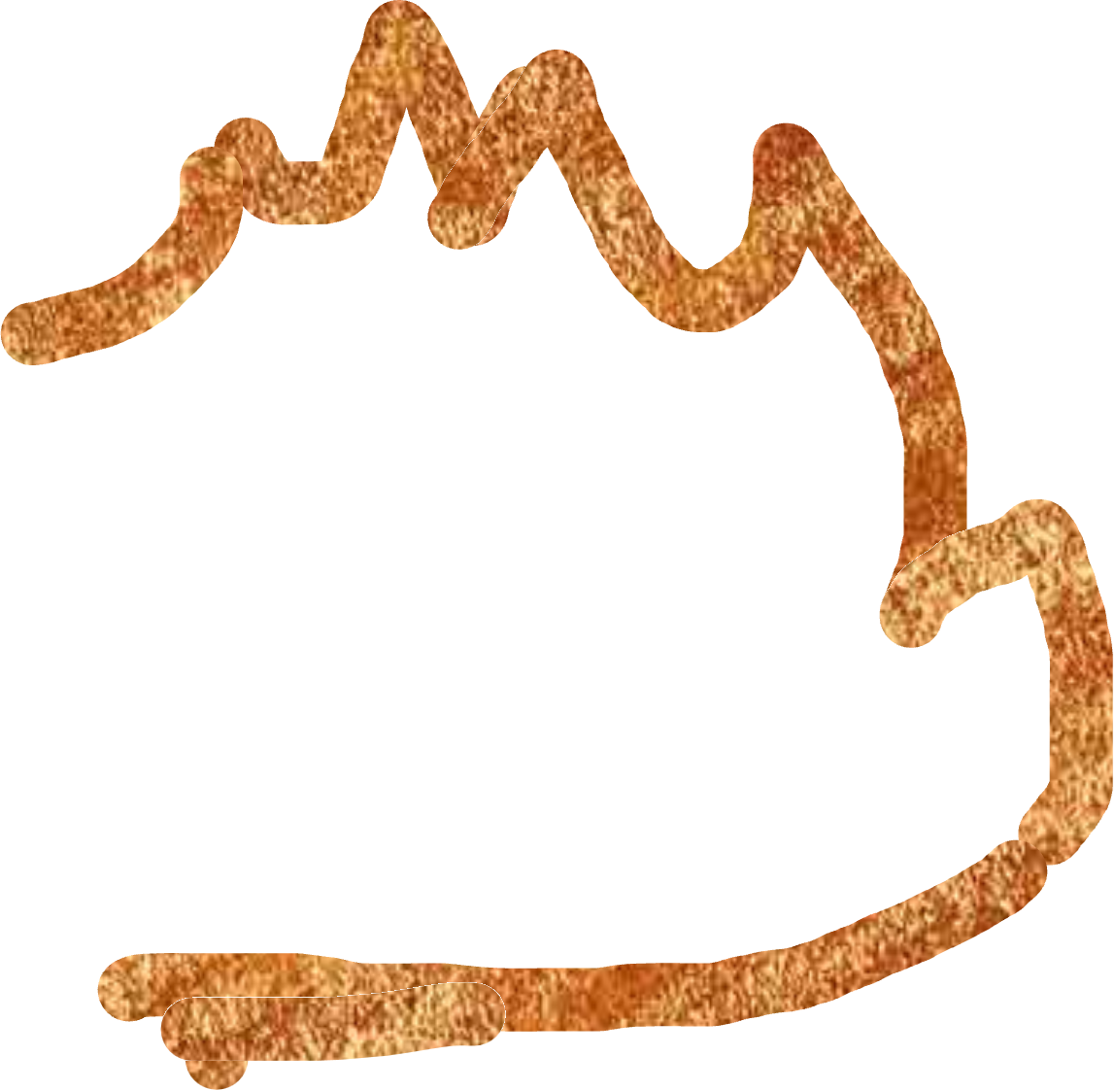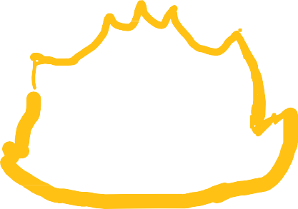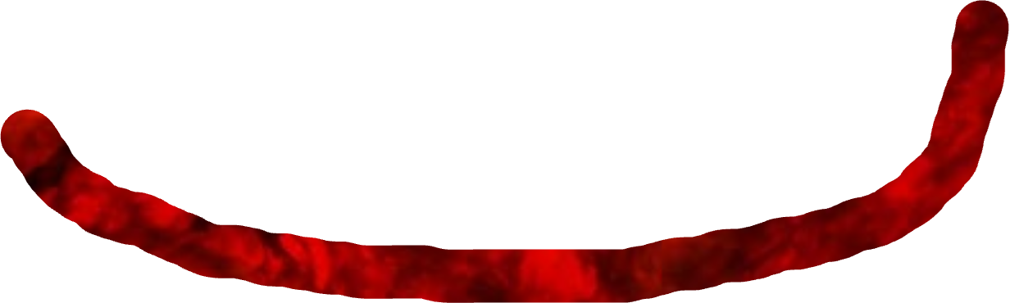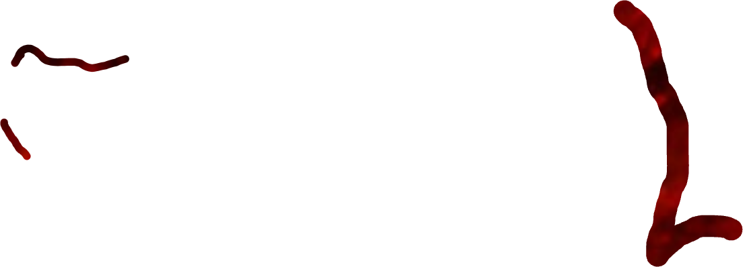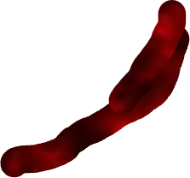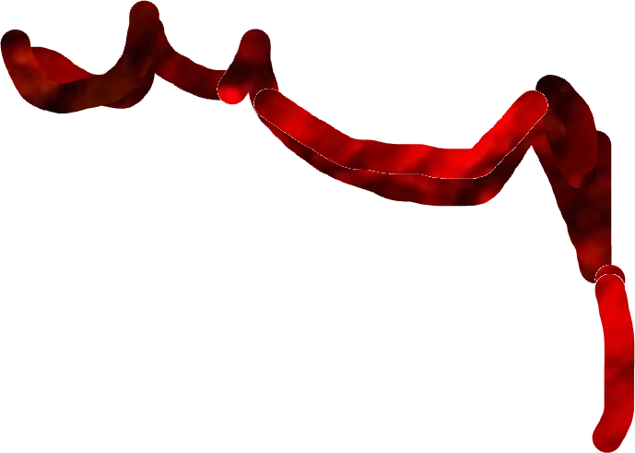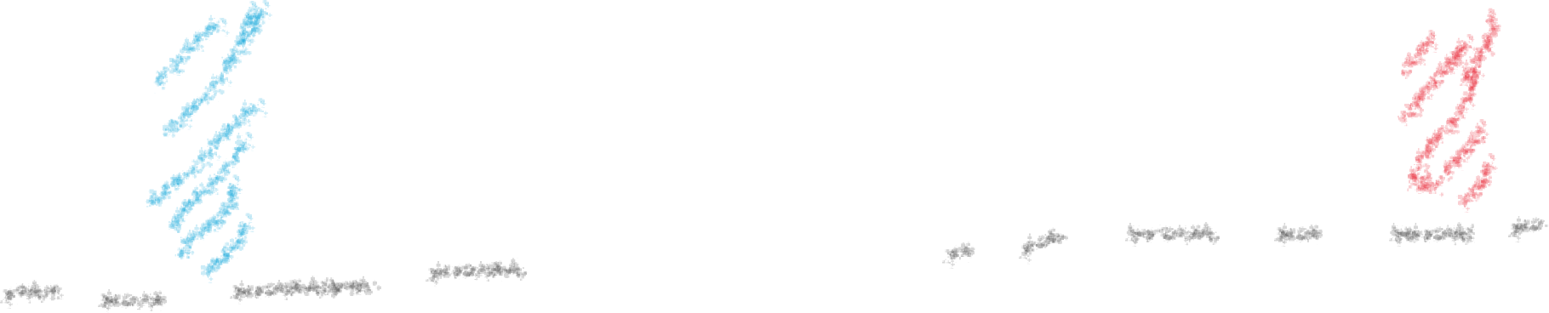

These include non-verbal cues (a part of body lang. as to opening up). Eg: Like alpha males in a band of Gorillas.)

# Pride –

Where an expression of victory is shown.

# Assertive –

To have a strong stance and being headfast on an opinion.

# Power Poses:

High Power Low Power Poses Poses

# Standing In Social Quicksand –

PPl. feel uncomfortable to open up to other ppl. or perons of authority who are expressionless.

# Fake it’ till you BECOME IT !!!

Presence

* Change our body posture & it changes our life.
* Judgements are predicted by 70% of outcomes of audiences from a senate house, which are made from certain non- verbal gestures.
* Body lang. can be greatly gender based. Women tend to feel much less powerful than Men. Eg: A sample of ppl. taken from an MBA classroom showed that.
* Non-verbal cues govern the way we think and feel about ourselves. Eg: We smile when we our forced to, but still makes us feel happy! So, it’s true to an extent that, »»Fake it till we make it!... Body thus, changes our mind.
* Hormones dictate the way we think. Experimental studies are in the below graph. These are physiological hormones such as Testosterone & Cortisol. Testosterone governs dominance while cortisol governs stress.

Risk Tolerance Testosterone Change Cortisol Change

20%  15% for low

80%

60% 10% ← 25% ←

for high

* Ppl who generally took risks had a higher % of success rates while there was a testosterone level increase in those who showed body lang. power and similarly decrease in the hormone, and stress was also inversely proportional.

Prescence was related to optimism & abstract thinking.

Passionate

Authentic

* + Role change can change minds.
  + That changes behaviour.

Confident

Comfortable

Enthusiasti

Captivatin

* + Behavior changes outcomes. Tiny tweaks - Makes a BIG Change !!!