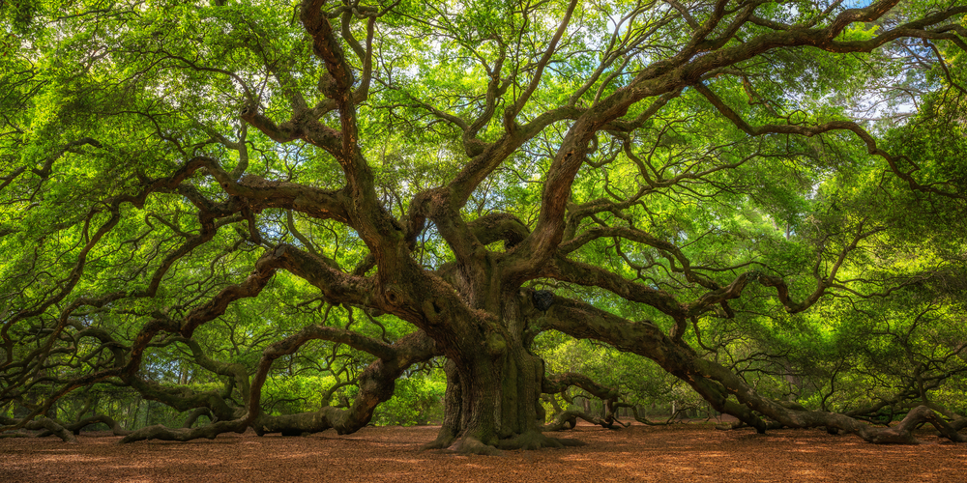

A tree planted in good soil is like planting a seed of knowledge in a person that grows over time. Teachers act like gardeners, creating the ideal environment for their charges to grow. Branches stand for various fields of knowledge, while roots signify a solid foundation. Education should be adaptable to meet individual requirements, much as trees do to their surroundings. In the end, both trees and learning reach their full potential, they both need time, patience, and care.

A tree is a great symbol of learning. We can learn from the trees how to give freely, without any discrimination or segmentation. We can learn how to be patient and live the seasons, adapt with what life will bring to us.