I used a previous class I led as a framework to build off of and revise. I wanted to try pulling each strategy out and highlighting what that looks like in a more everyday situation. The example I have below is trying to get students to recognize filters they are most likely using all the time.
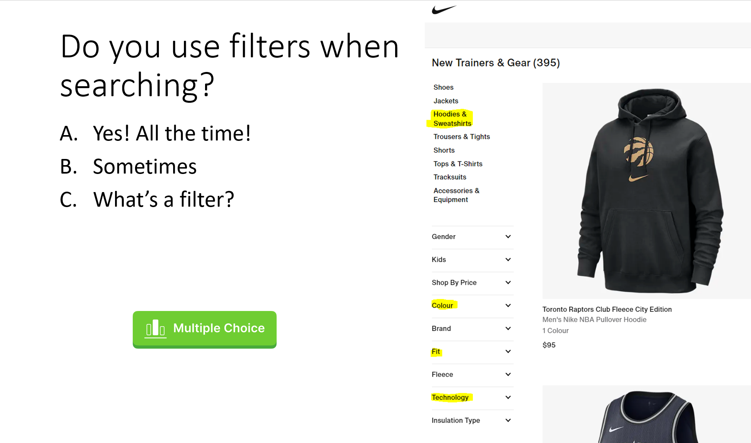
After this interactive question, I would head to a library database and ask students to identify where the filters are located there. An individual or group activity would follow where students would be asked to test filters to see what they do. I would then lead into another interactive response where students would write a short description of a filter.
