Plan for a SoTL Project
by Lisa Macdonald, St. Lawrence College, Kingston
Research Question
What are you curious about?
What would you like to know about strategies that might hinder and/or help students to learn, in your course?
Do you want to know if an activity, assignment, or teaching strategy “works?”
Do you have a question about how to help your students learn a particular skill?

I used design thinking model to think about my research question. I started with an empathy map which helped me to understand student needs and concerns.

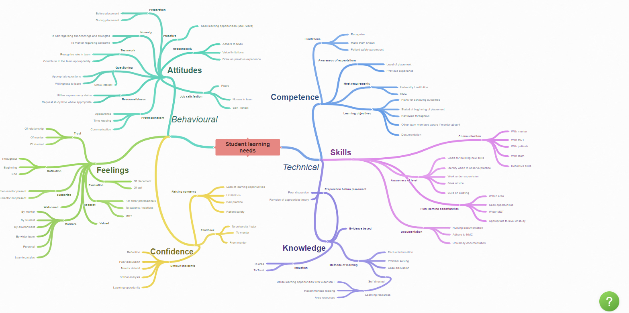
What are the best student-centered engagement activities to implement in an active learning classroom? How do we create inclusive equitable types of activities to engage various learning styles? What teaching strategies can effectively facilitate the adaptation of international students to a new learning environment, particularly in addressing challenges related to adjusting to different teaching styles and academic cultures, and how do these strategies impact their engagement and academic performance?
Identify challenge/outcome related to learning that is related to your question.
Describe the learning in a way that suggests how you might measure it using either qualitative or quantitative methods.

To measure this, multiple methods could be used – Feedback through
Qualitative method could involve conducting semi-structured interviews with students one to one. Question might explore their comfort levels with various teaching styles, their preferences, and how well they feel they comprehend material presented in different formats.

Additionally, a quantitative approach could involve surveys s assessing students' perceptions of their understanding and engagement in classes using different teaching methods. Combining both methods could provide a comprehensive understanding of how international students perceive and adapt to various teaching styles, offering insights into effective approaches for their successful integration into the new learning environment.

Describe the instructional activity, assignment, or teaching strategy that will promote student learning on the outcome you identified.
I have found the use of case studies effective in my human resources course. I would like to challenge the students to work through real life scenarios to reinforce their learning.
I usually make comparisons with the home countries to draw them out and find similarities and differences.
I also would like to use an art- based approach – in activities like ice breakers or team-building exercises in classrooms or group settings. Collaborative art projects or group murals can foster communication, teamwork, and a sense of belonging among diverse groups of students.
Describe the evidence that would persuade an external audience that the new or modified teaching strategy improves student learning on the targeted learning outcome.
I would like to offer students the opportunity to reply to questions through diverse ways of their choice (written, video, artistically). Observations of students' participation levels and their expressions during these activities can provide qualitative insights into their adjustment process. Pre- and post-workshop surveys assessing students' comfort levels, sense of belonging, and understanding of the new environment could also be employed to quantify changes in perceptions or attitudes following art-based interventions.
How and where would you publish, present, or disseminate this work?
I would share my ideas with my peers and colleagues within our college and others from other local colleges

Consent and Cultural Sensitivity:

Informed Consent: Ensure students understand the purpose and potential outcomes of art-based activities. Respect their choice to participate or abstain without pressure.
Confidentiality and Privacy:
Sharing Personal Stories: Encourage artistic expression without forcing students to reveal personal or sensitive information. Respect their right to privacy and confidentiality regarding their artwork and narratives shared during activities.
Support and Emotional Safety:
Emotional Well-being: Some art-based activities might evoke strong emotions or memories. Offer support services or guidance for students experiencing emotional distress.
Respect for Expression: Respect diverse perspectives and interpretations expressed through art. Avoid judgment or bias towards specific artistic expressions.

Reflecting for Disseminating Your SoTL Project

I would start by Identifying my
- Audience:
Academic Community: Scholars, educators, and researchers interested in pedagogy, cross-cultural education, or student adaptation.
Institutional Stakeholders: Administrators, faculty development teams, or diversity and inclusion offices within educational institutions.
International Student Support Services: Professionals working directly with international students' well-being and academic success.
2. Dissemination Channels:
Academic Journals: Submitting articles to peer-reviewed journals specializing in education, cultural studies, or pedagogy.
Workshops or Webinars: Hosting workshops or webinars to share findings with educators, providing actionable insights and strategies.
Online Platforms and Blogs: Creating blog posts or articles on educational websites, forums, or social media to reach a broader audience interested in educational practices. I have let my students create blogs and podcasts.
3. Tailoring the Message:
Clearly articulate my research findings, emphasizing actionable recommendations for educators to enhance support for international students. Last year I had done a presentation at the learning conference.
Accessible Language: Communicate findings in a way that is accessible and understandable to diverse audiences, avoiding jargon or overly technical language. Recently I allowed students to write in their native language and translated to see what they expressed.

4. Collaborations and Partnerships includes engaging with Stakeholders:
Collaborate with institutions, organizations, or networks working with international students to disseminate findings effectively.
Involve Participants: Share findings with participants involved in the study, acknowledging their contributions and insights.

5. Timeline and Planning:
Create a Timeline: Plan the dissemination activities, considering the publication process, conference schedules, or workshop arrangements.
Allocate Resources: Allocate resources for dissemination efforts, whether it's time, budget, or assistance required for presenting or publishing findings.

6. Evaluation and Feedback:
Assess Impact: Evaluate the effectiveness of dissemination efforts by collecting feedback from audiences about the usefulness and applicability of the findings.
Iterative Approach: Consider iterative dissemination, updating or refining the message based on audience feedback for better engagement.

Adapted from: C. J. Stanny, E. M. El-Sheikh, & H-M. Chung (2009) Getting Started with a SoTL Project
Center for University Teaching, Learning, and Assessment http://uwf.edu/cutla/

