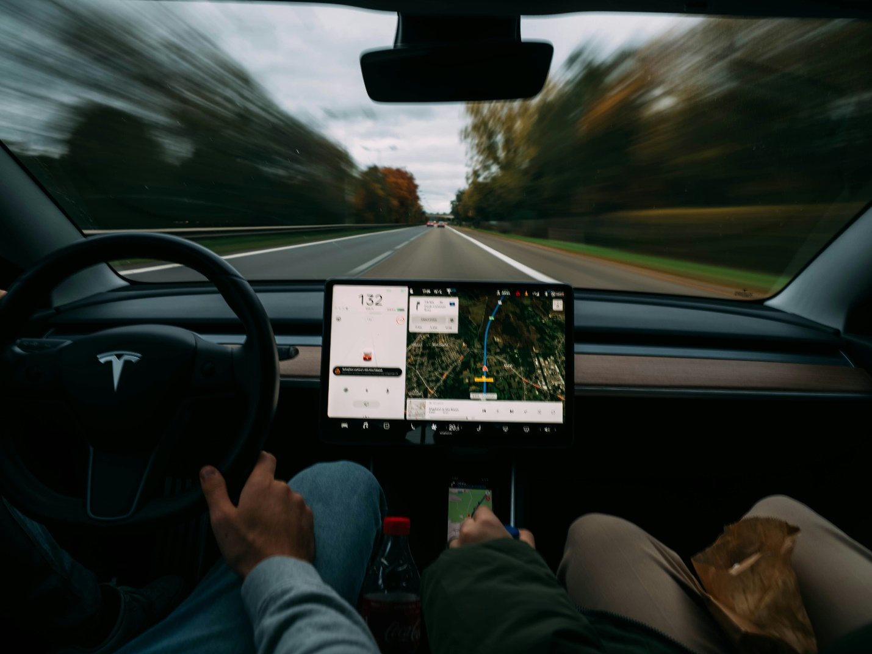
Photo by Brecht Denil on Unsplash
https://unsplash.com/photos/2-person-sitting-on-car-seat-TDfMJT78J70

At the beginning of each semester, I feel my class is starting a journey and I am their GPS that will assist them to reach their destination. I will provide instructions, support, and guidance during the journey, but the students are the drivers.
During the journey the students will need to follow rules, instructions, and with my assistance/feedback to overcome challenges. As a GPS (instructor) my job is to ensure the students are following the right path to learning and enjoying the ride. To improve students’ motivation it is important to celebrate the milestones and take in the view as the students drive to the final destination.

