Rena Gandham

Curator Module – Activity 4 – Holy CRAAP

Part 1 and 2

Documentation tool

CRAAP Test
Resource Title:
Performance Appraisal Process - check for understanding
Resource URL:
https://h5pstudio.ecampusontario.ca/content/41344
Currency: The timeliness of the information:
When was the resource published or posted?
Has the resource been revised or updated?
Does your topic require current information?
Are the links functional?
When was the resource published or posted? June 14, 2022
Has the resource been revised or updated? No
Does your topic require current information? No
Are the links functional? Yes
Relevance:&nbsp;The importance of the information for your needs
Does the resource relate to your needs?
Who is the intended audience?
Is the information in the resource at an appropriate level for your learners?
Does the resource relate to your needs? Yes
Who is the intended audience? Students in Human Resources Management courses
Is the information in the resource at an appropriate level for your learners? Yes
Authority: The source of the information
Who is the creator?&nbsp;
What are their credentials or organizational affiliations?
Are they qualified to write on this topic?
Who is the creator? Sue Pratt
What are their credentials or organizational affiliations? Professor, Durham College
Are they qualified to write on this topic? Yes
Accuracy:&nbsp;The reliability and truthfulness of the information
Is the information supported by evidence?
Has the resource been reviewed or refereed?
Are there spelling, grammar, or typographical errors?
Is the information supported by evidence? No
Has the resource been reviewed or refereed? No
Are there spelling, grammar, or typographical errors? No
Purpose:&nbsp;The reason the information exists
Why does this resource exist? (to inform, teach, sell, entertain, or persuade?)
Is the information fact, opinion, or propaganda?
Are there political, ideological, cultural, religious, institutional, or personal biases?
Why does this resource exist? (to inform, teach, sell, entertain, or persuade?) - to teach/assess the students' understanding
Is the information fact, opinion, or propaganda? No
Are there political, ideological, cultural, religious, institutional, or personal biases? No
Notes:&nbsp;Are there additional questions or observations you have about this material that affect your decision to use it? (i.e. this is an opinion piece that I will use to demonstrate one side of an argument).
This to check the understanding of the Appraisal Methods
Final Recommendation:&nbsp;Will you use this resource? Why or why not?
Yes, to assess my students understanding of the Performance Appraisal methods.

Part 2 – Link to my Padlet post

https://padlet.com/extend_ecampusontario/curation-as-creation-creation-as-curation-5ow548i6cxsbpoyd/wish/2900969138

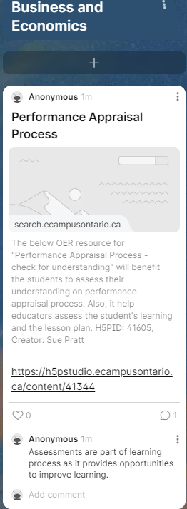

Based on CRAAP my comments to other people’s posts on Padlet

https://padlet.com/extend_ecampusontario/curation-as-creation-creation-as-curation-5ow548i6cxsbpoyd/wish/2901085701

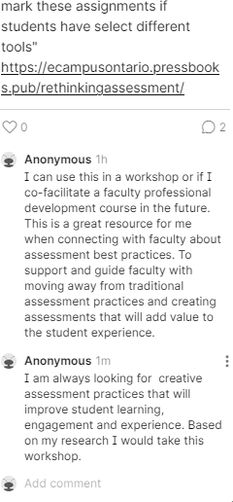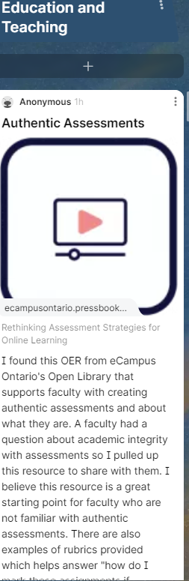

https://padlet.com/extend_ecampusontario/curation-as-creation-creation-as-curation-5ow548i6cxsbpoyd/wish/2862388728

