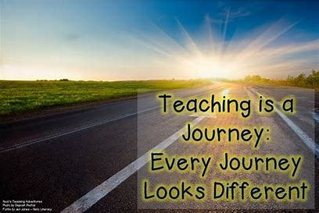

I chose this picture as, in my role, I’m trying to lead my students through the whole program and be there for them as an instructor, as a mentor, and as a friend. Support my students as they explore new ideas and concepts, offering directions and navigating them through the educational landscape. I tend to believe in their success, and at the end of the journey, we celebrate this success together.