“I am not alone…
Beyond speaking those words, I need to believe I’m not alone for these battles in the mind are invisible, but fierce, and we are fighting to lift ourselves up from them, breaking free to reclaim lost confidences and beliefs in our worth—in our purpose—in our dreams.
We are not alone…” (Evans, 2019)
I chose this article and this particular nugget because I felt it resonated so deeply with me and students that I have seen. So many of us start off life confident and free, however over time we begin the negative self-talk journey, constantly putting ourselves down, telling ourselves we can't do things and giving ourselves undeserved guilt. I have seen students do this too. Telling themselves that they are stupid or dumb and so they can't do the work, anxiety and panic raising up in them at the thought of failing. It's heart breaking that we do this to ourselves. I want to help students to see that they are not alone and that they can overcome their negative self-talk and see themselves for the smart, creative, wonderful individuals that they are. It is a journey but one that we are not on alone. We are together on this journey and the end is bright!
*I created this image using bing AI image generator and canva.
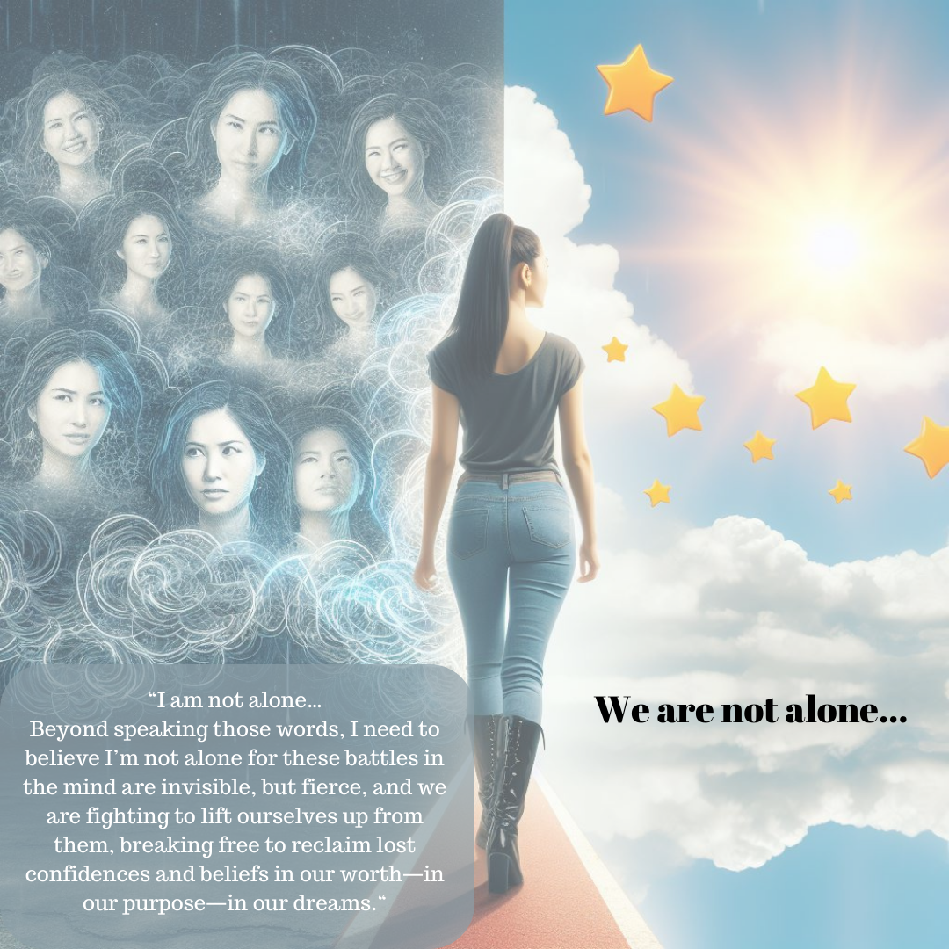
Reference
Evans, T. (2019, November 7). Openness, vulnerability, and self care: The open faculty patchbook. The Open Faculty Patchbook | A Community Quilt of Pedagogy. https://openfacultypatchbook.org/self-care/patch-thirty-eight-vulnerability-and-self-care/

