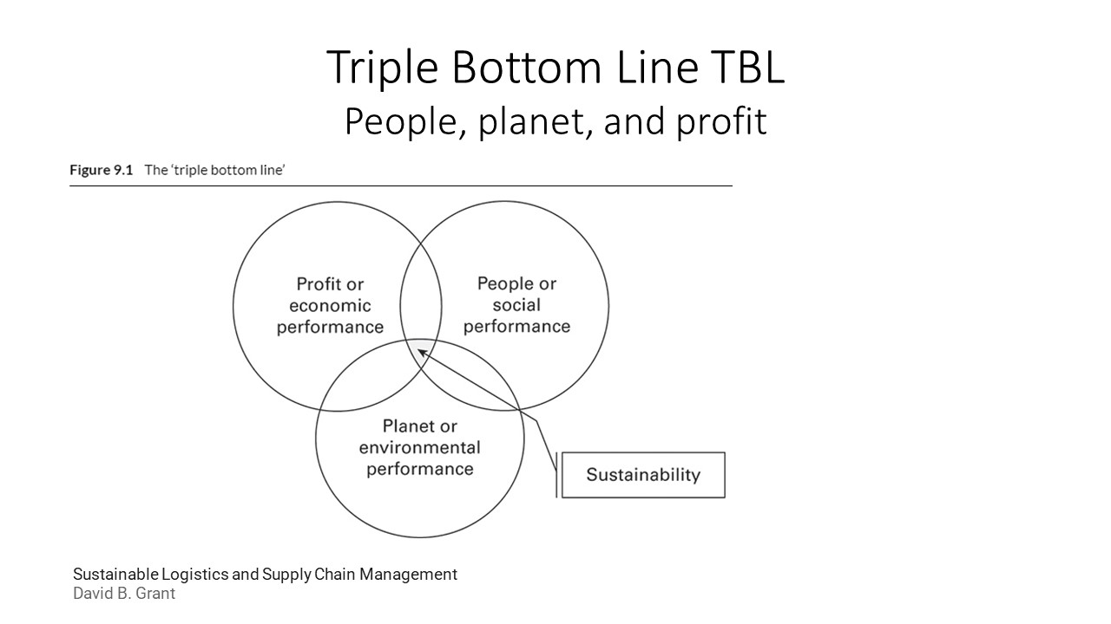
https://www.youtube.com/watch?v=ijSSe66865w

Case studies
Examples of redesigned business models for new opportunities MillerCoors MillerCoors has recognized that its products (beer) have a major impact on society. Consequently, it has developed and implemented a comprehensive program that embraces all aspects of sustainability—the social, environmental, and financial capital. This is a plan that is moving MillerCoors toward reducing the amount of water needed to make one gallon of beer—the goal is 3:1 in an industry where craft breweries typically use anywhere from 6 to 10 gallons to make one gallon of beer. The plan involves developing a sustainable supply chain through collaboration and education. The plan also involves MillerCoors helping communities deal with the adverse effects of drinking by focusing on reducing/eliminating underage drinking and on encouraging responsible consumption and designated drivers. Through the plan, MillerCoors has set a goal to ensure that by 2020 43 percent of the management will consist of women and minorities. It is a plan that strives to change the culture of MillerCoors. The results have positively affected MillerCoors’ public image, its top line (revenue) and its bottom line (profits). Amazon Amazon, one of the world’s largest e-retailers, has embraced sustainability both within the company and in the supply chain. It has focused on improving the sustainability of packaging within the supply chain, beginning with the packaging at Amazon. Consequently, it has introduced Frustration-Free Packaging— programs designed to promote shipping products in their own packages without additional shipping boxes and easy-to-open, 100 percent recyclable packaging. These initiatives have grown to include over 1.2 million products and have eliminated more than 36,000 tons of excess packaging in 2015 alone. Amazon has also pushed sustainability through the supply chain by requiring each supplier to ensure that their suppliers and subcontractors conform to the standards and practices of Amazon’s Supplier Code of Conduct—a standard that covers areas such as health and safety in production and working areas, the right to legal wages and benefits, prevention of child labor or forced labor, and fair and ethical treatment (including non-discrimination). Amazon has been known to terminate any supplier that either violates the Code or does not cooperate with the auditors. McKinsey and Company McKinsey and Co predicts $380 billion in potential annual net material cost-saving opportunities in the European Union (EU) from the adoption of “circular” business practices. In this system, value is created by looping products, components, and materials back into the value chain after they fulfill their utility over the life of the product. To realize the full resource productivity opportunity, firms will need to work across circular supply chains, analyze how raw materials are extracted, components produced, products designed, and how return markets are organized, while also considering new business models such as leasing products to customers to retain ownership of materials embedded in the products. Reference: Developing sustainable supply chains to drive value – Volume 2 By Dr. Robert P. Sroufe | Dr. Steven A. Melnyk

https://www.youtube.com/watch?v=ijSSe66865w

