MISUNDERSTOOD ACTIVITY:
CORRRELATION DOES NOT IMPLY CAUSATION

The video A Private Universe which explains how students revert back to their intuitive misconceptions and how these misconceptions persist even after having learned about them, made me think of the concept that correlation does not imply causation. This concept seems simple enough for students that just because statistical analyses show a significant correlation between two variables, meaning that we discover the strength and direction of the relationship between two variables, it does not provide us with information about cause and effect. In fact, most already know the concept as it has almost become a mantra: “Correlation does not imply causation”. However, outside the classroom, when the examples are not as straightforward and there are headlines or trending topics that imply or make claims about the benefits, effects, or X leads to Y, based on correlational results, just like the students in the Harvard video, the students revert back to their prior misconception that if a relationship (correlation) between two events exists and seems to intuitively makes sense then it must be true that one causes the other.
The Harvard video reveals that we must first make students aware of their misconceptions in order for them to truly learn the new concept. I would attempt to do that by showing the students at the beginning of class a few headlines that make claims of causation based solely on correlational findings and ask them what they think of these claims and whether they are true.
Then, I would explain in depth the concept of correlation, its uses and benefits, and how it does not indicate causation. Next, I would show them the websites Spurious Correlations and Spurious Scholar created by Tyler Vigen. These sites show statistically significant correlations between silly and random variables that are turned into charts and even have AI generated academic research articles based on these spurious correlations with AI generated funny images and explanations of the false causal connection.
Finally, I would ask the students to go on these sites and create their own AI generated chart or research paper based on spurious correlations of their choice. Hopefully, once the students experiment and see for themselves how easy it is to find a link between variables and make it look legitimate with charts and even AI generated research papers claiming that there is a cause and effect between these random variables, that they will let go of their misconception and question whether to believe headlines, ads, politicians, etc. making claims about causality based on correlational research.

I would use the following image for my analogy:

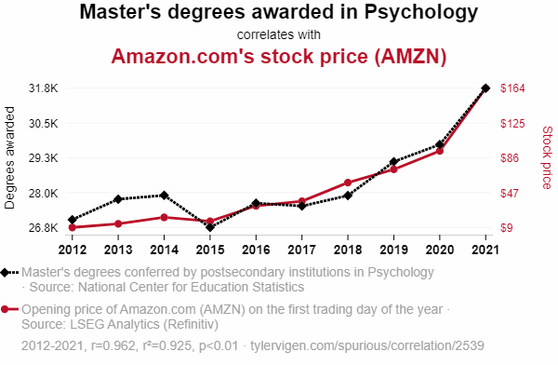

AI explanation
As more people became qualified to analyze behavior and make predictions, they all realized that the urge to buy things we don't need on Amazon is deeply rooted in the human psyche. This heightened awareness led to a surge in online shopping, driving up Amazon's stock price. It's like a virtual shopping session for the soul, with a prime connection to the subconscious.

Produced by the Harvard-Smithsonian Center for Astrophysics. 1987.
Introduction to Psychology Copyright © 2021 by Southern Alberta Institution of Technology (SAIT) is licensed under a Creative Commons Attribution 4.0 International License, except where otherwise noted. https://openeducationalberta.ca/saitintropsychology/chapter/correlation-vs-causation/
https://www.tylervigen.com/spurious-correlations CC BY 4.0
https://www.tylervigen.com/spurious-scholar CC BY 4.0
https://tylervigen.com/ CC BY 4.0
Image by Tyler Vigen https://www.tylervigen.com/spurious/correlation/2539_masters-degrees-awarded-in-psychology_correlates-with_amazoncoms-stock-price shared under a Creative Commons (BY) license. CC BY 4.0

